Install Virtualbox/VMware Workstation with different flavours of linux or windows OS on top of your present windows environment.

AIM:
To install VMware Workstation and install a different flavour of Linux/Windows Operating System as a virtual machine on the existing Windows environment.

PROCEDURE:

STEP 1: Go to VMware Workstation.
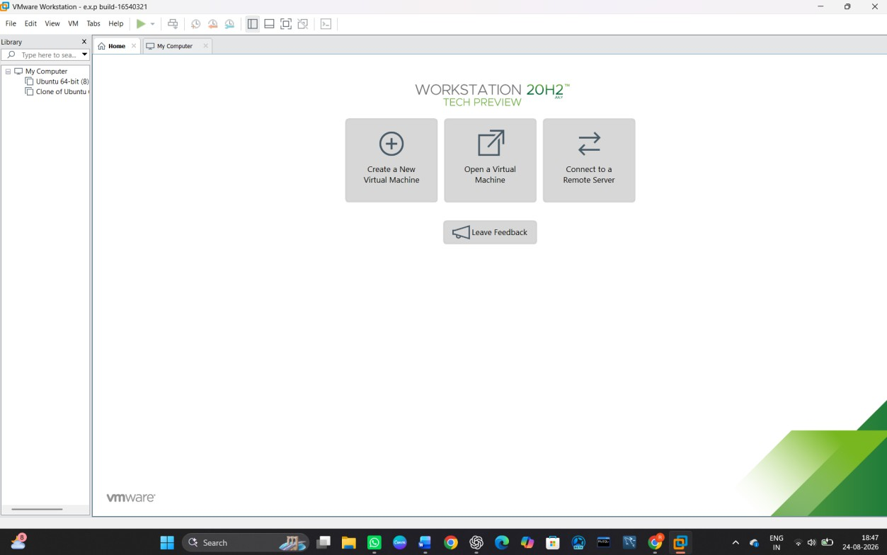

STEP 2: Click on Create a New Virtual Machine.

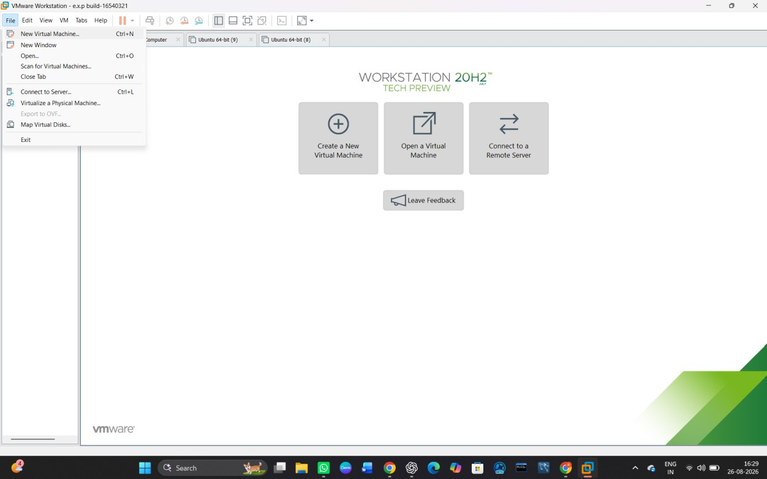

STEP 3: Select Typical (Recommended) and click Next.
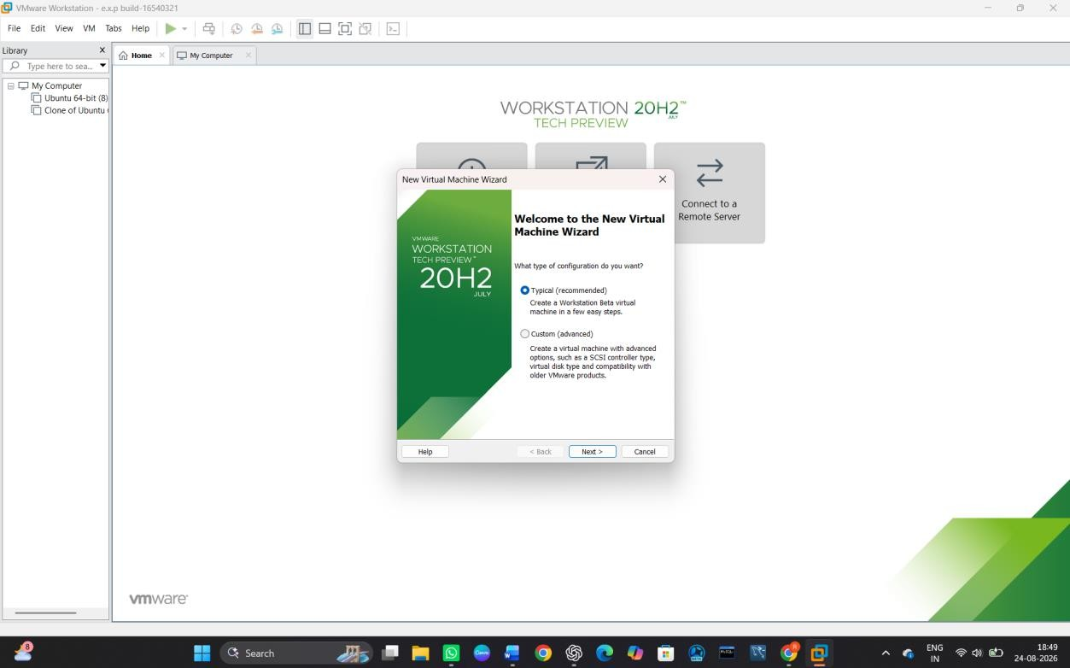

STEP 4: Select the ISO image file of the Linux/Windows operating system.

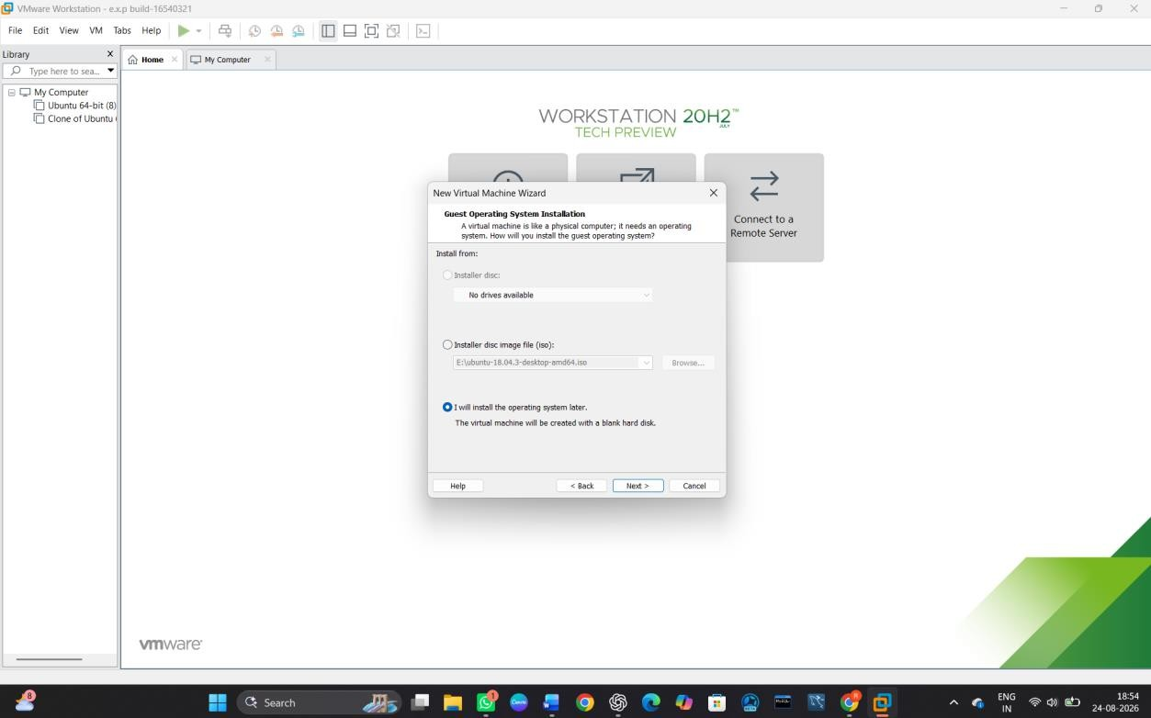
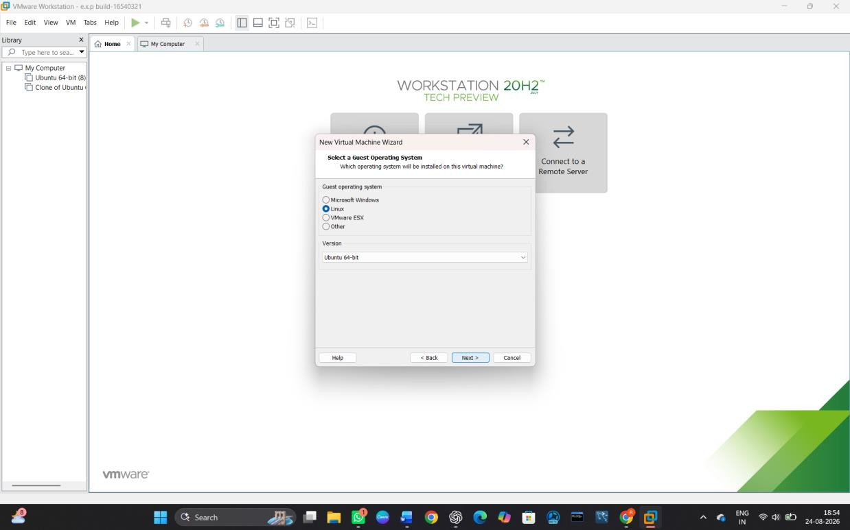

STEP 5: Enter the Virtual Machine Name and select the storage location.

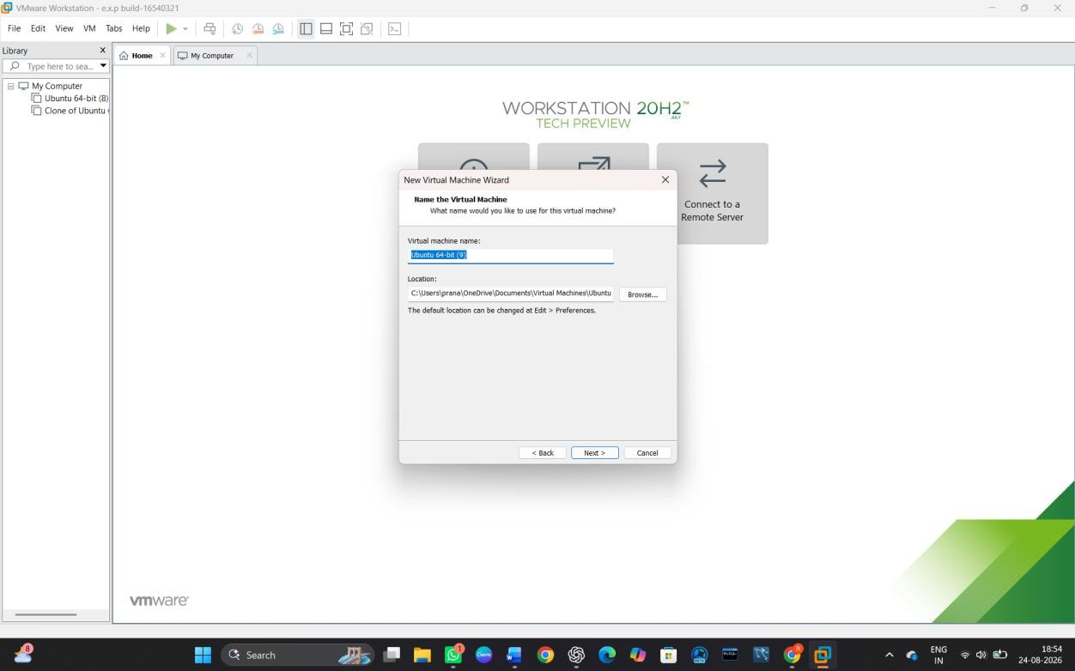

STEP 6: Specify the required disk size and click Next.
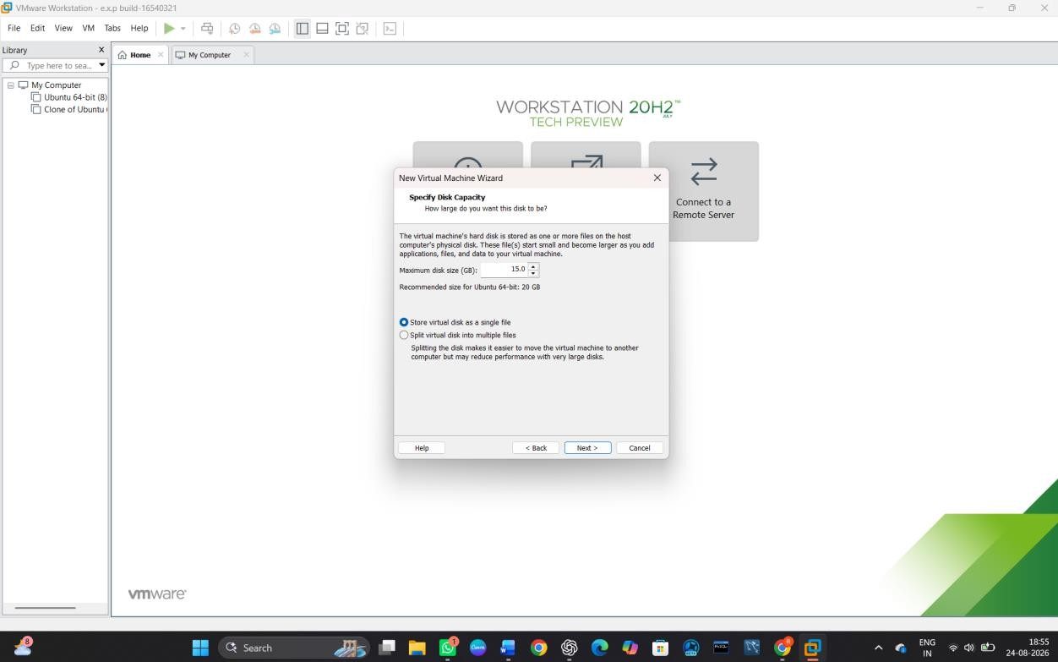

STEP 7: Click on Customize Hardware and configure the required RAM and processor.

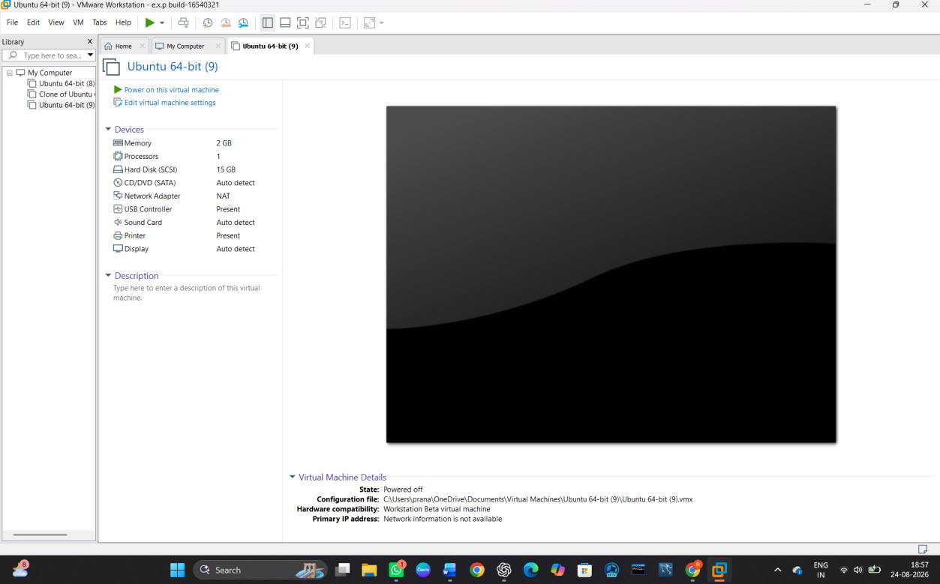

STEP 8: Click Power on this virtual machine.
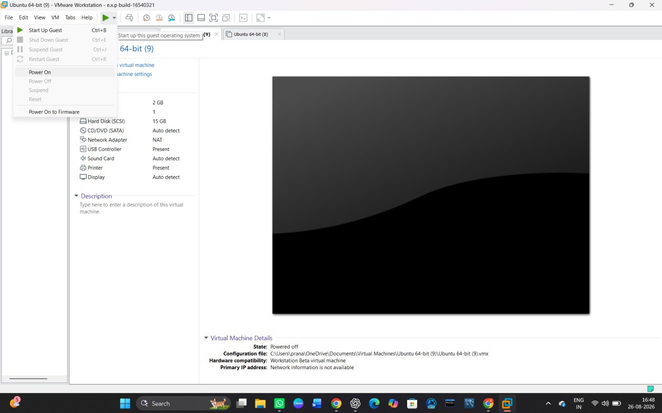

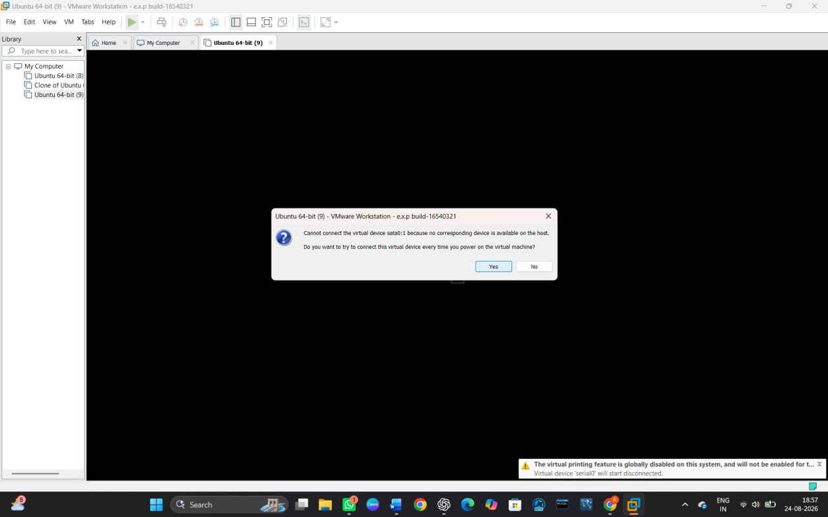

STEP 9: Install the selected Linux/Windows operating system by following the installation instructions.
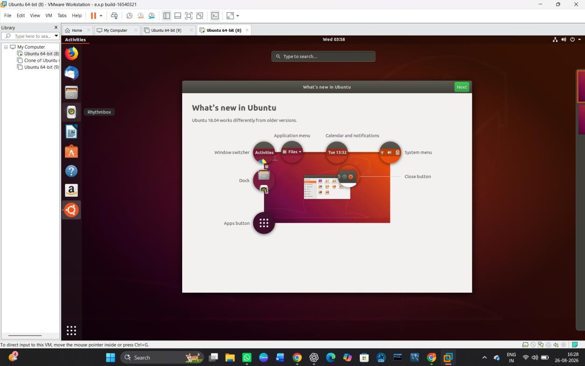

Install a C compiler in the virtual machine created using virtual box / VM Ware Workstation / Player and execute Simple C Programs.

AIM:

To install a C compiler (GCC) in the virtual machine created using VMware Workstation and execute simple C programs.

PROCEDURE:
STEP 1: Go to VMware Workstation.
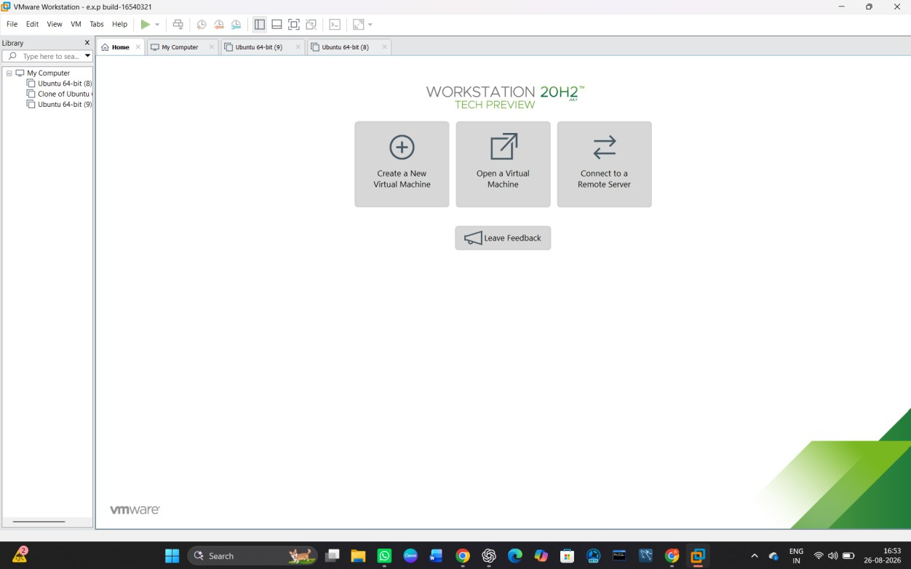

STEP 2: Start the Ubuntu virtual machine.

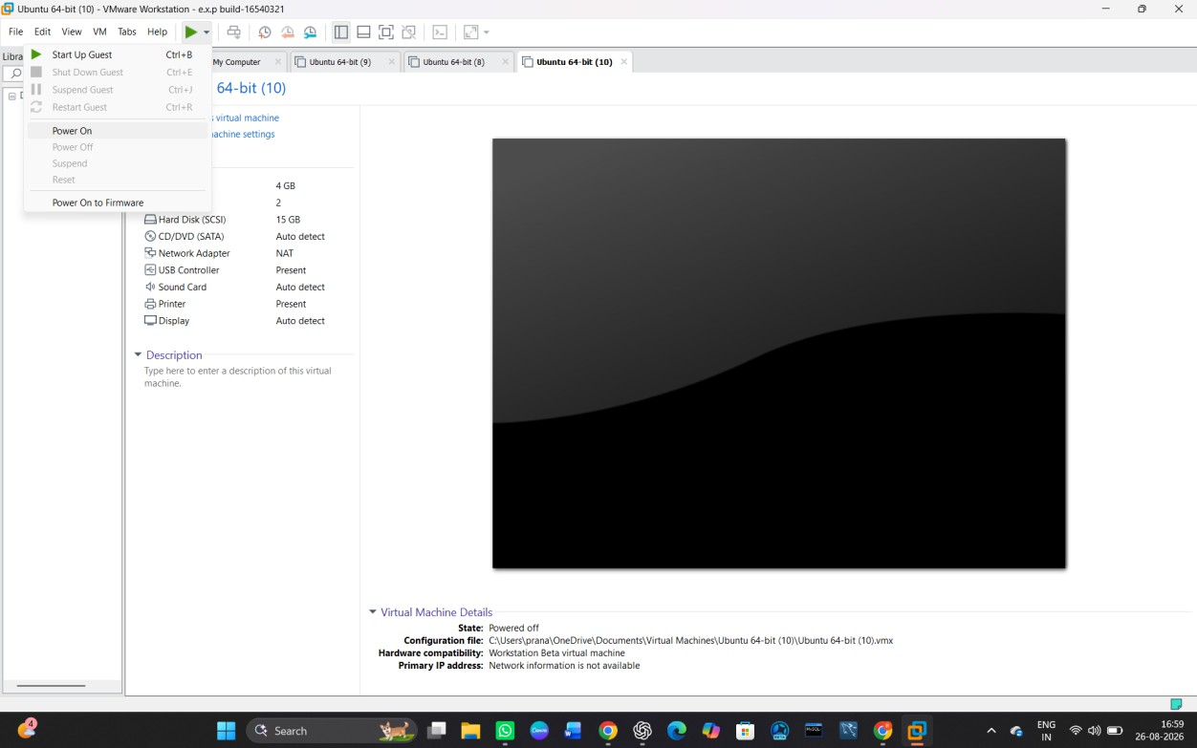

STEP 3: Open the Terminal in Ubuntu.
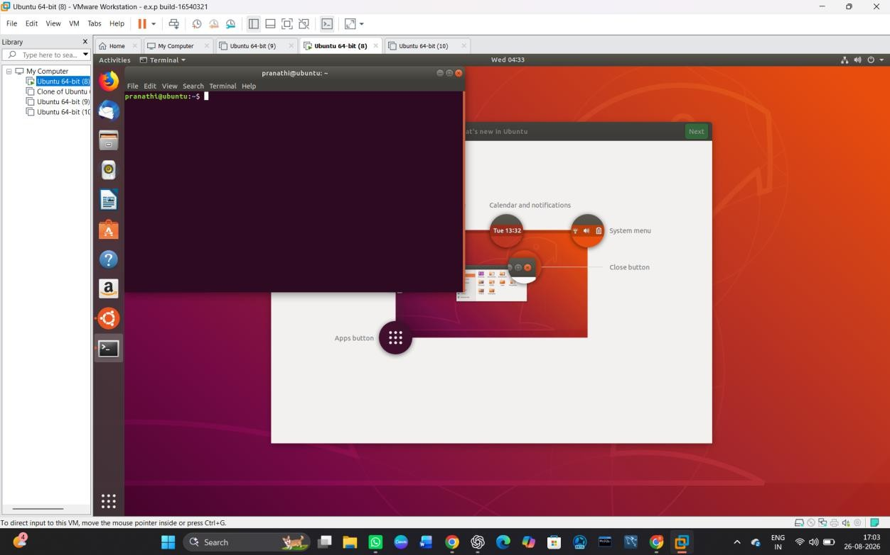

STEP 4: Update the package list using the command:

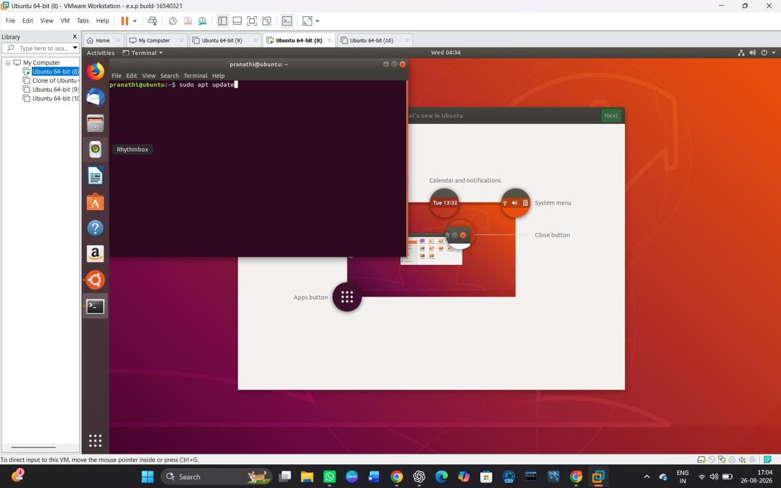

STEP 5: Install the GCC compiler using:
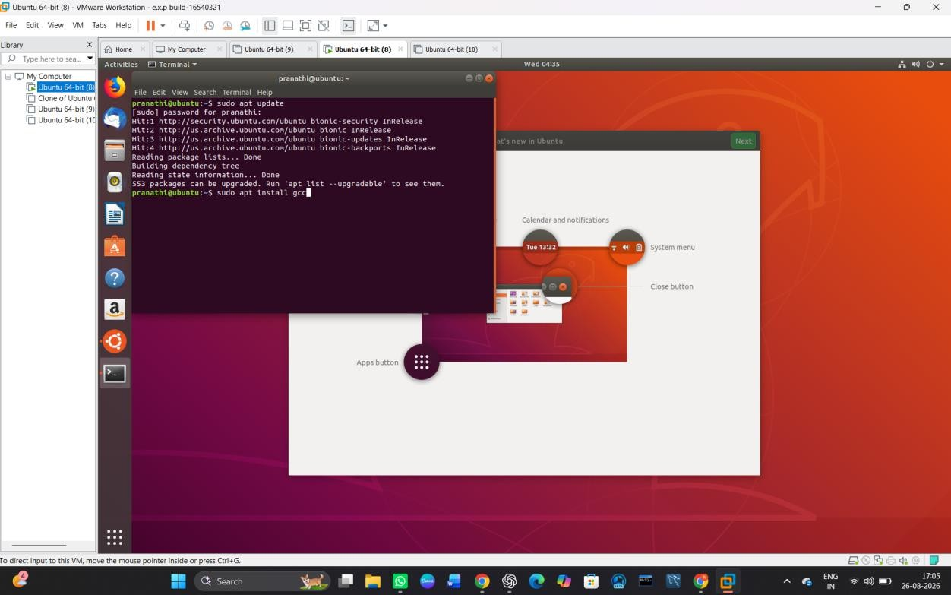

STEP 6: Check whether GCC is installed using:

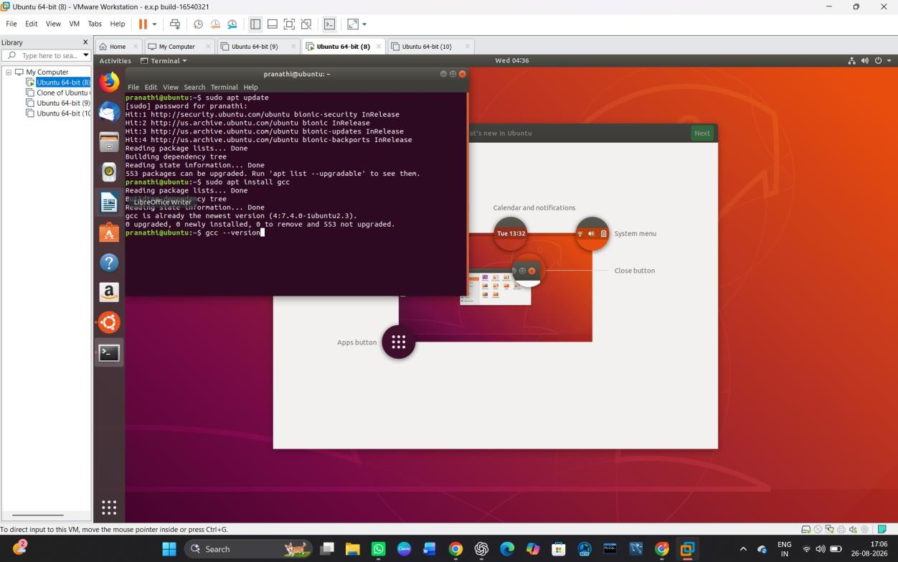

STEP 7: Create a C program using:
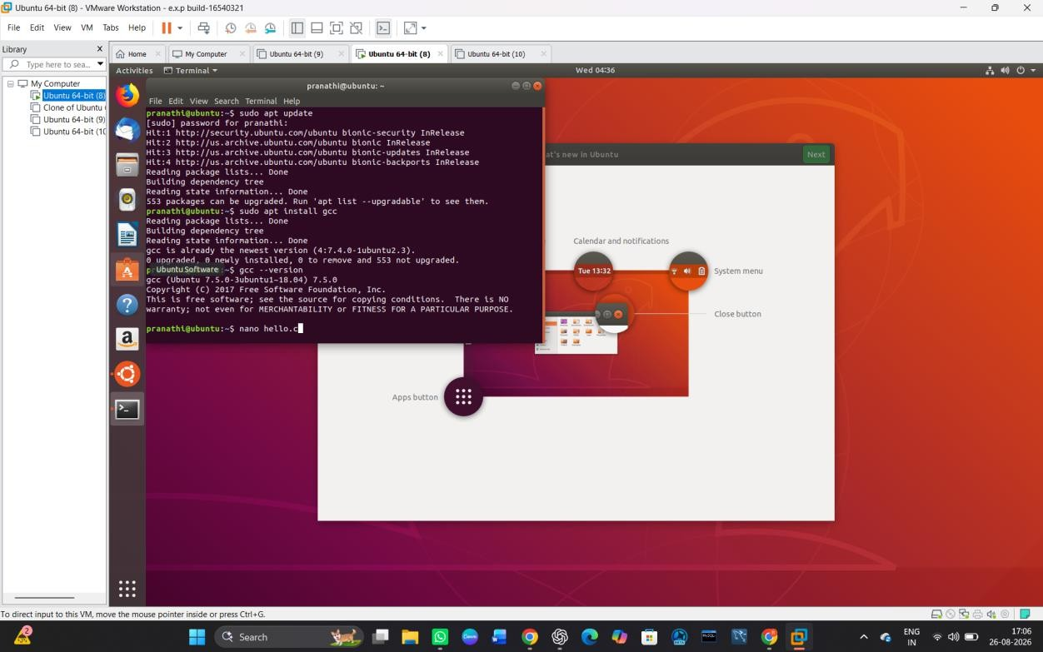

STEP 8: Enter a simple C program and save the file.

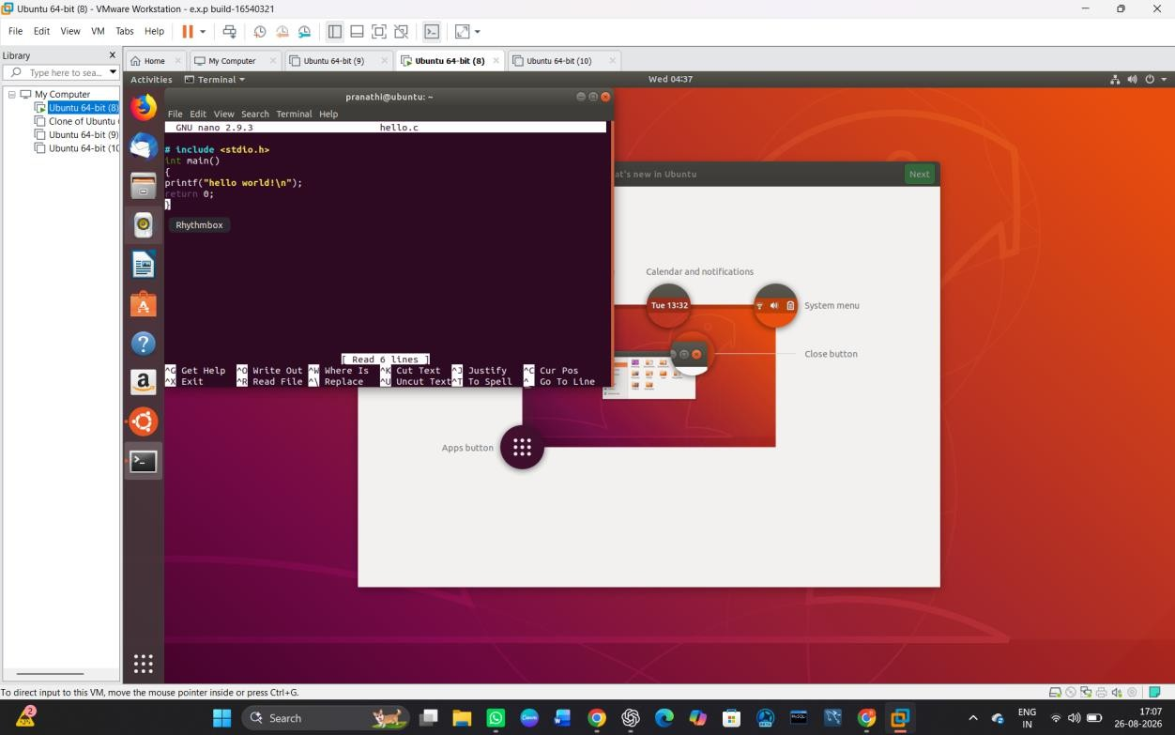

STEP 9: Compile the program using:
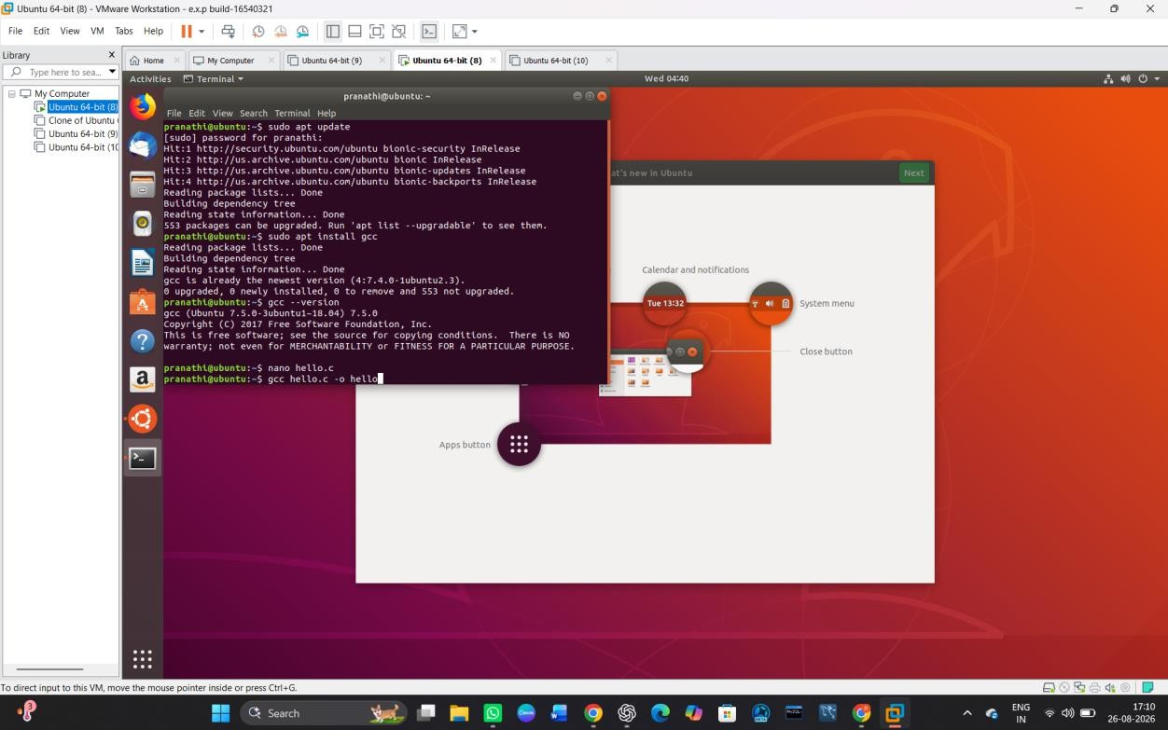

STEP 10: Execute the program using:

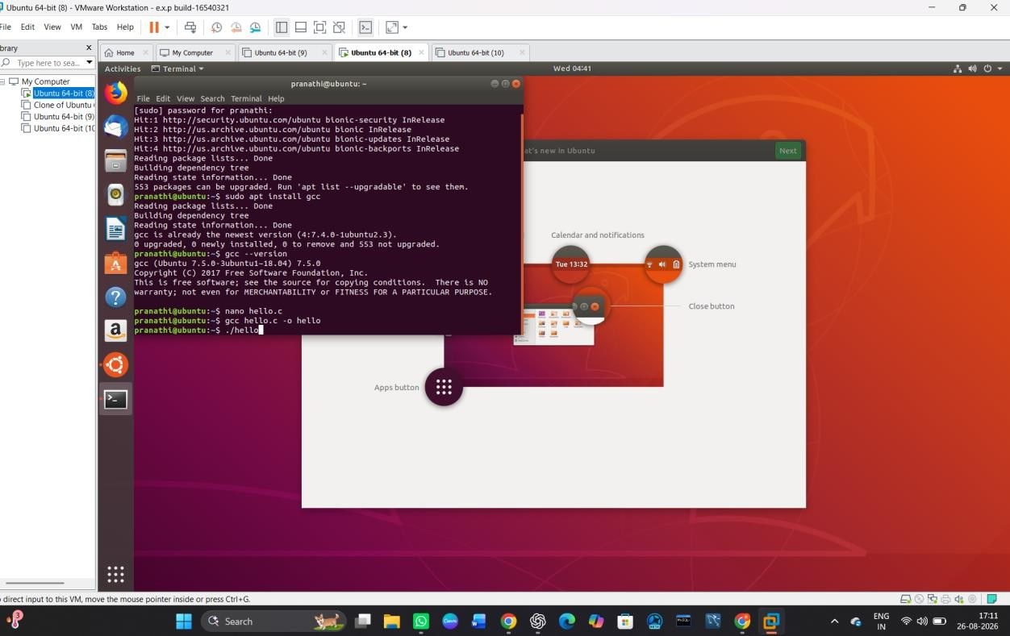
STEP 11: Succesfully Executed C program
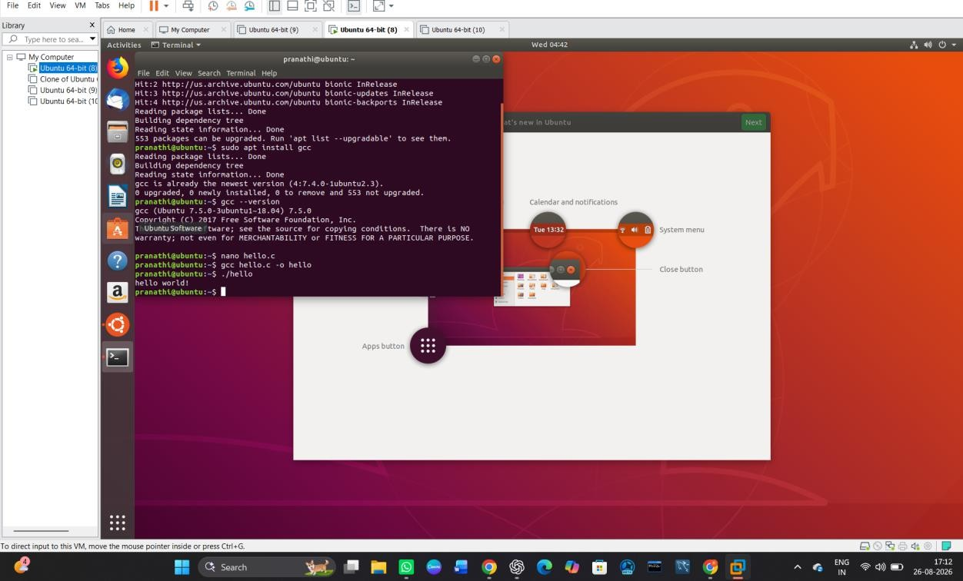

Install Virtualbox with different flavours of linux or windows OS on top of windows 10 using custom installation.

AIM:

To install Oracle VirtualBox with a different flavour of Linux/Windows Operating System on top of the existing Windows 10 environment using Custom Installation.

PROCEDURE:

STEP 1: Open VMware Workstation
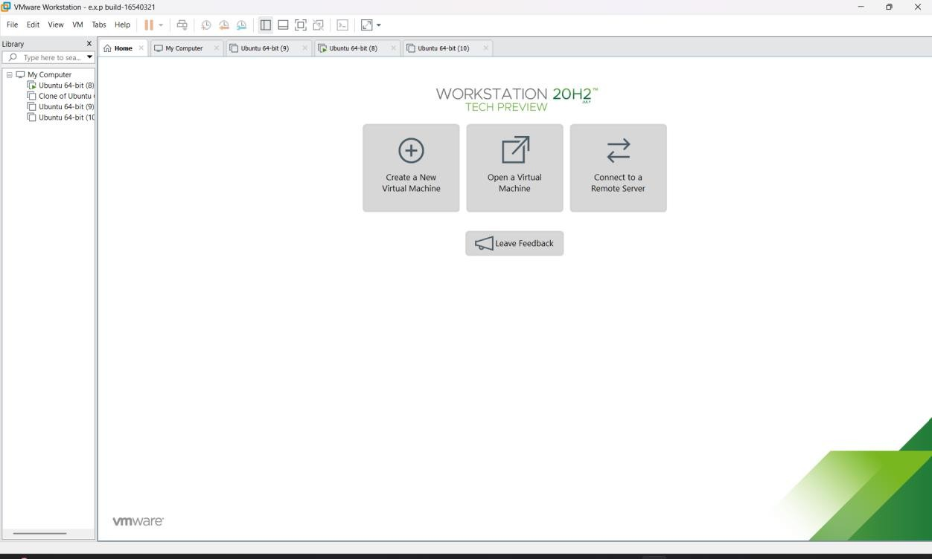

STEP 2: Create a New Virtual Machine

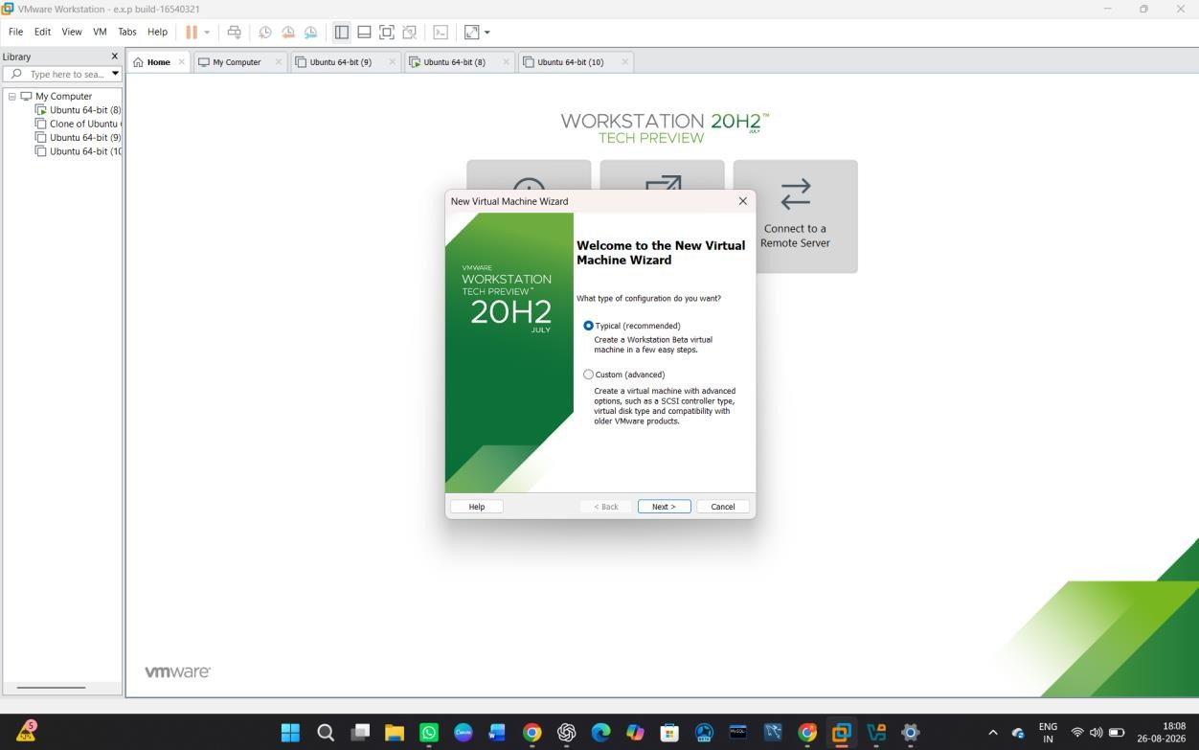

STEP 3: Select Ubuntu ISO
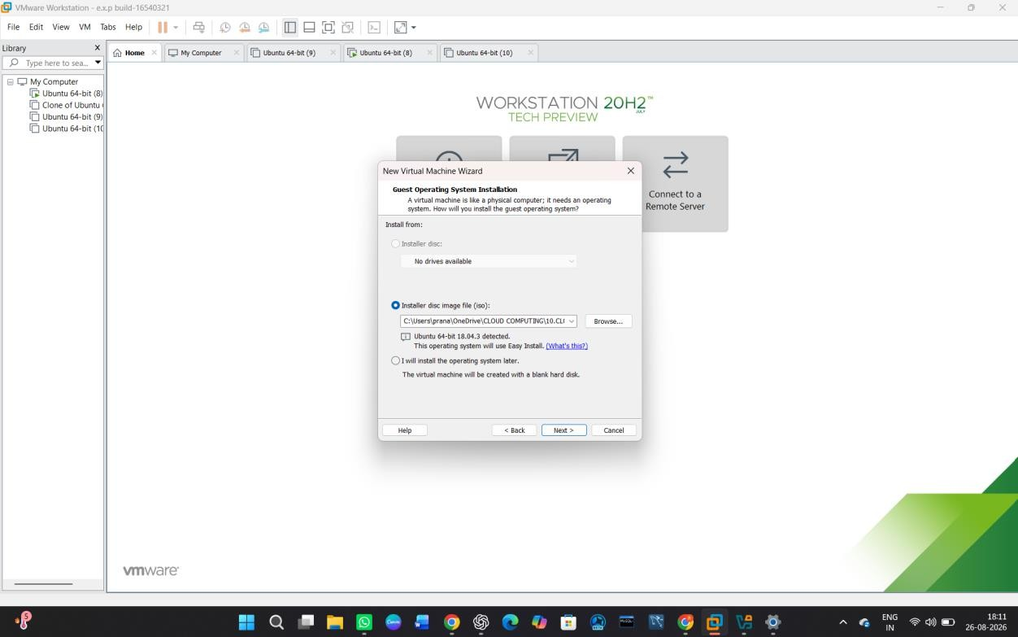

STEP 4: Give the VM a Name

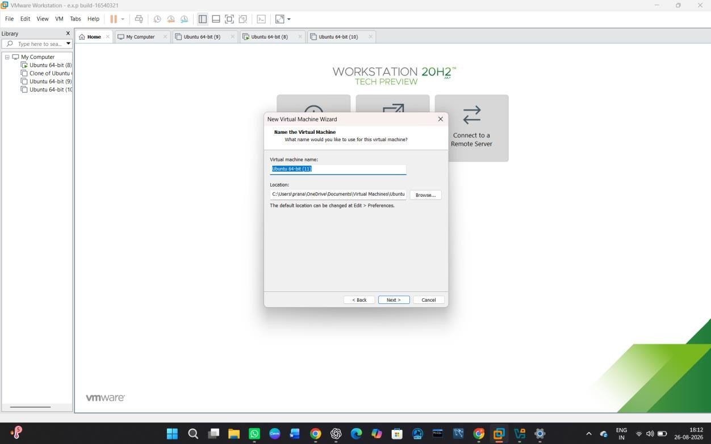

STEP 5: Configure the Virtual Disk
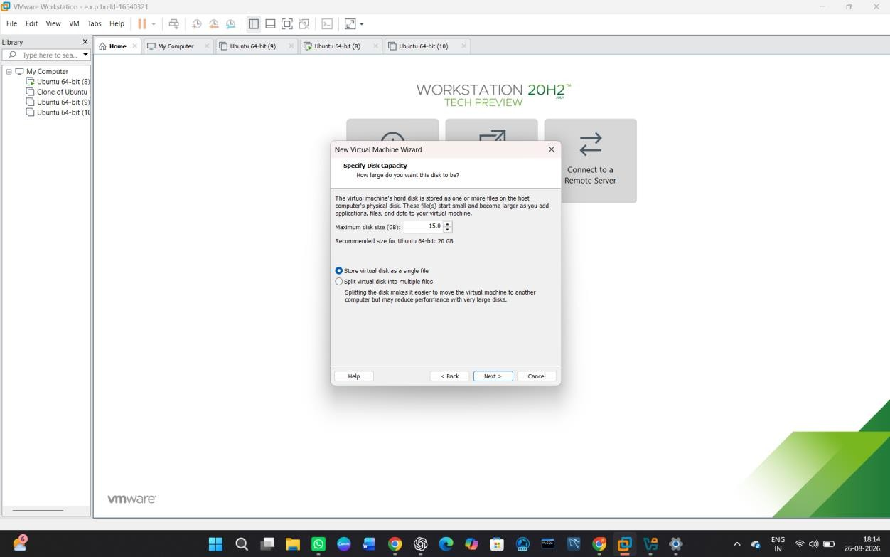

STEP 6: Customize Hardware

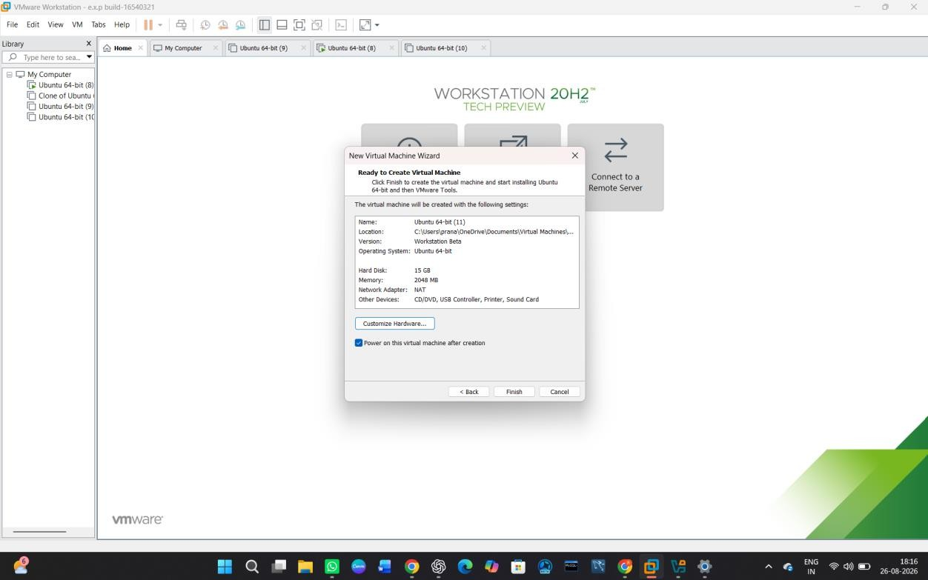

STEP 7: Start the Virtual Machine
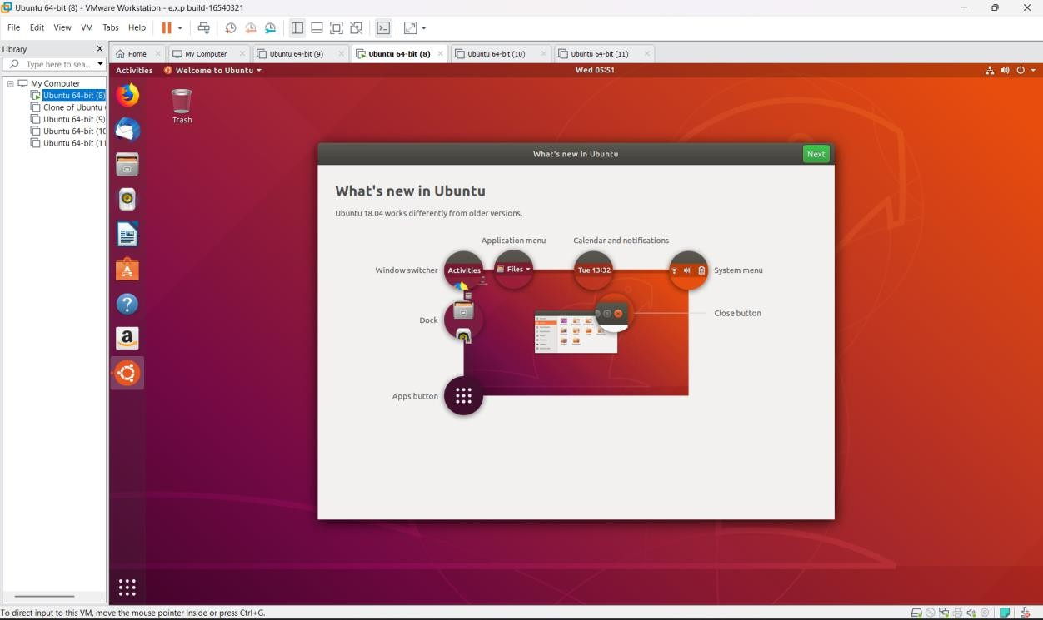

Install Virtualbox/VMware Workstation with different flavours of linux or windows OS on top of windows 7 or 8.

AIM:

To install VMware Workstation and install a different flavour of
Linux/Windows Operating System on top of the existing Windows 7/8 host environment.

PROCEDURE:

STEP 1: Go to VMware Workstation.


STEP 2 — Select the Virtual Machine Type



STEP 3 — Select the Ubuntu ISO


STEP 4 — Name the Virtual Machine


STEP 5 — Configure Disk Capacity


STEP 6 — Customize Hardware

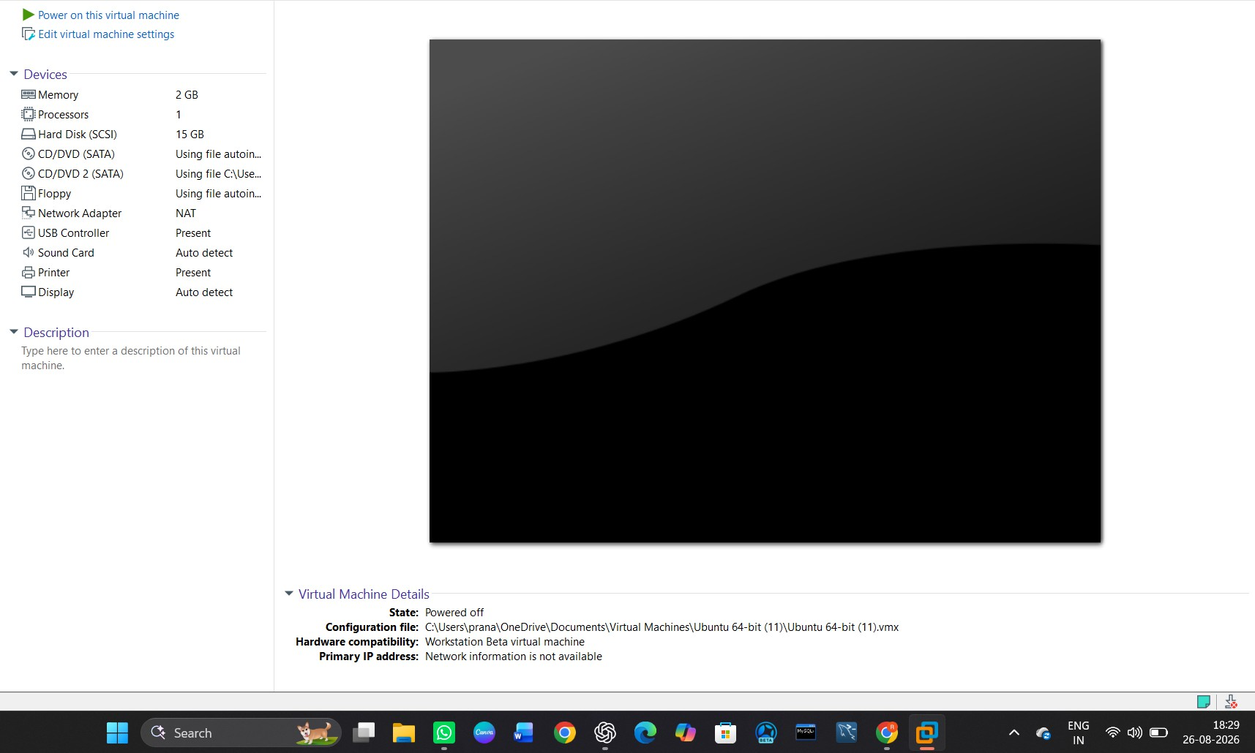
STEP 7 — Power On the Virtual Machine
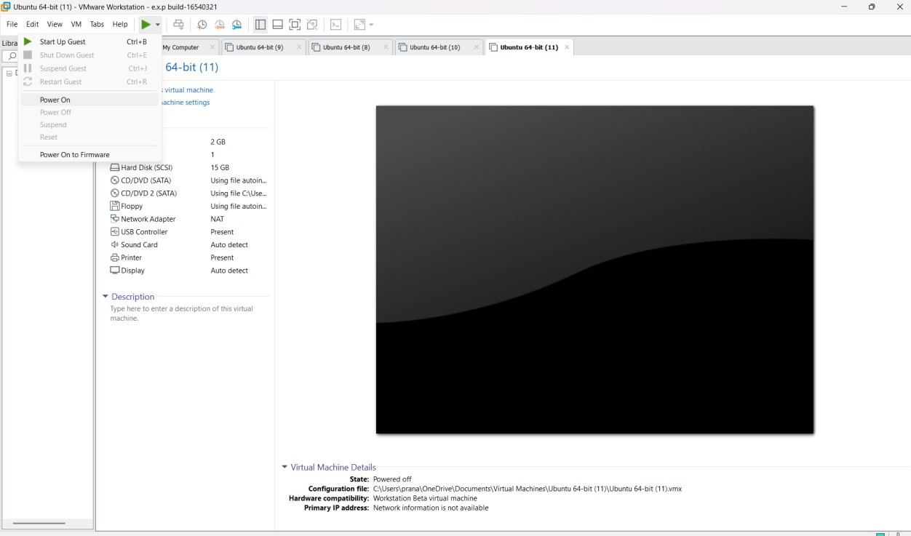

STEP 8 — Install Ubuntu and Login

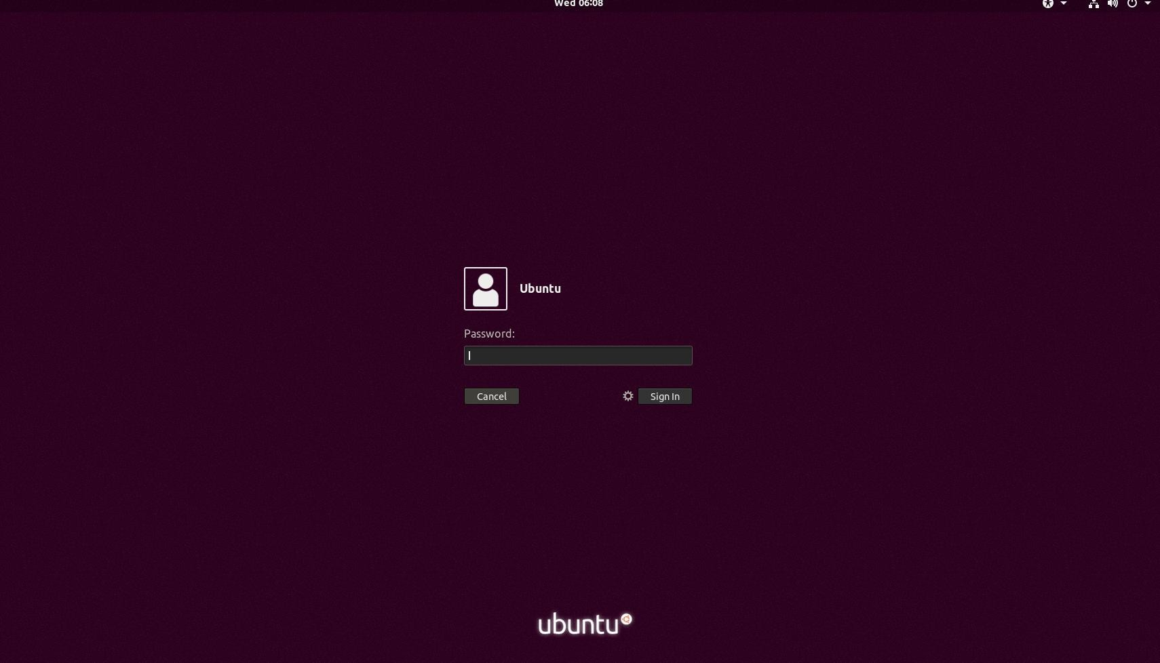

STEP 9 — Verify the Installation
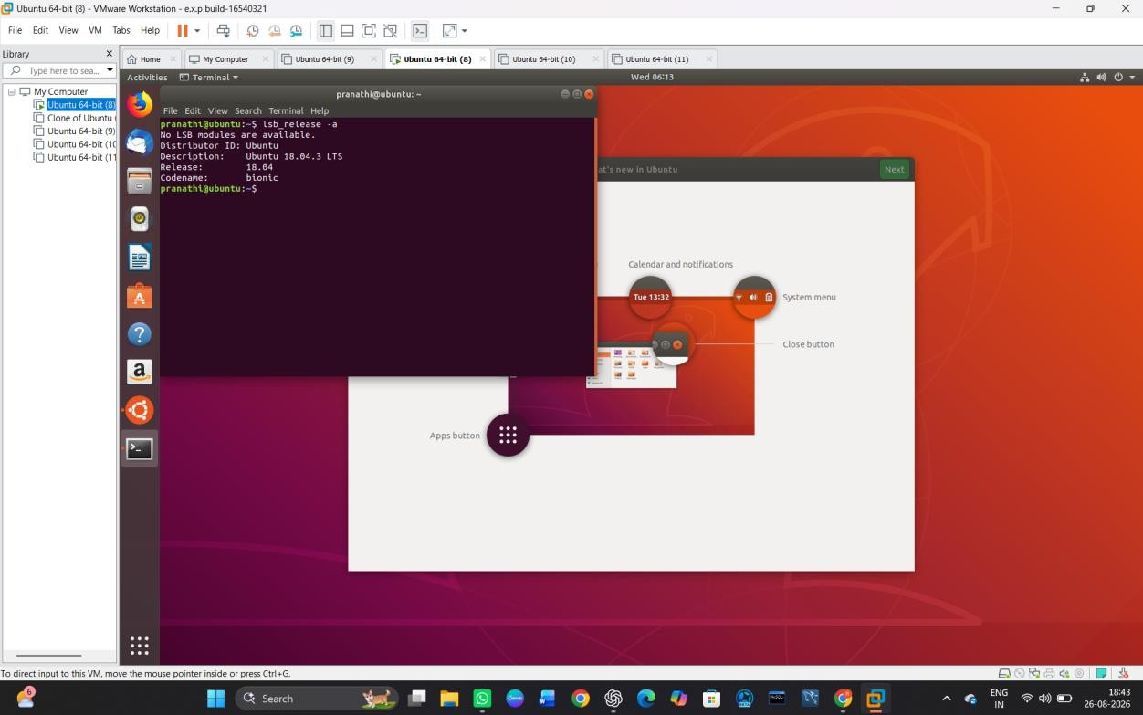

To write a procedure to run the virtual machine of different configuration and to check how many virtual machines can be utilized at a particular time.

AIM:

To run virtual machines with different configurations and determine how many virtual machines can be utilized simultaneously on a host system.

PROCEDURE:

STEP 1— Go to VMware Workstation.


STEP 2 — Check Your VM Configuration

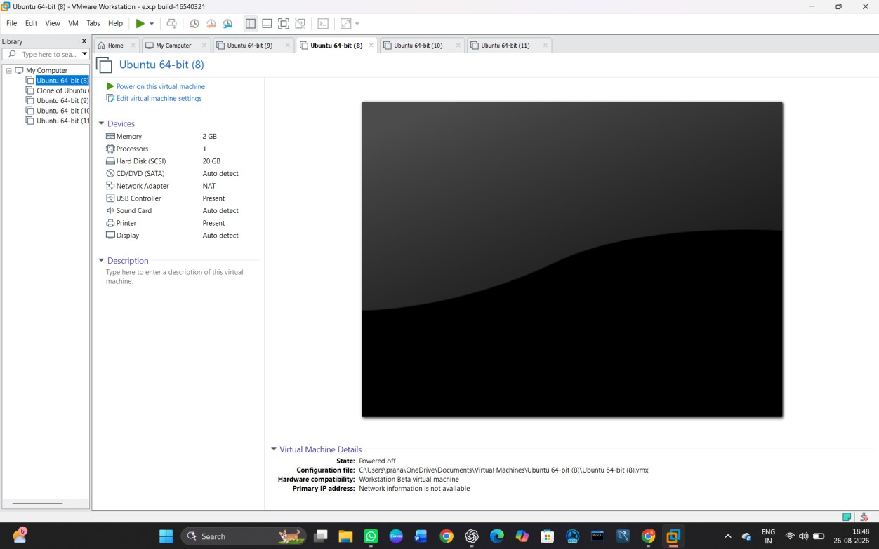
STEP 3 — Create the Second Virtual Machine
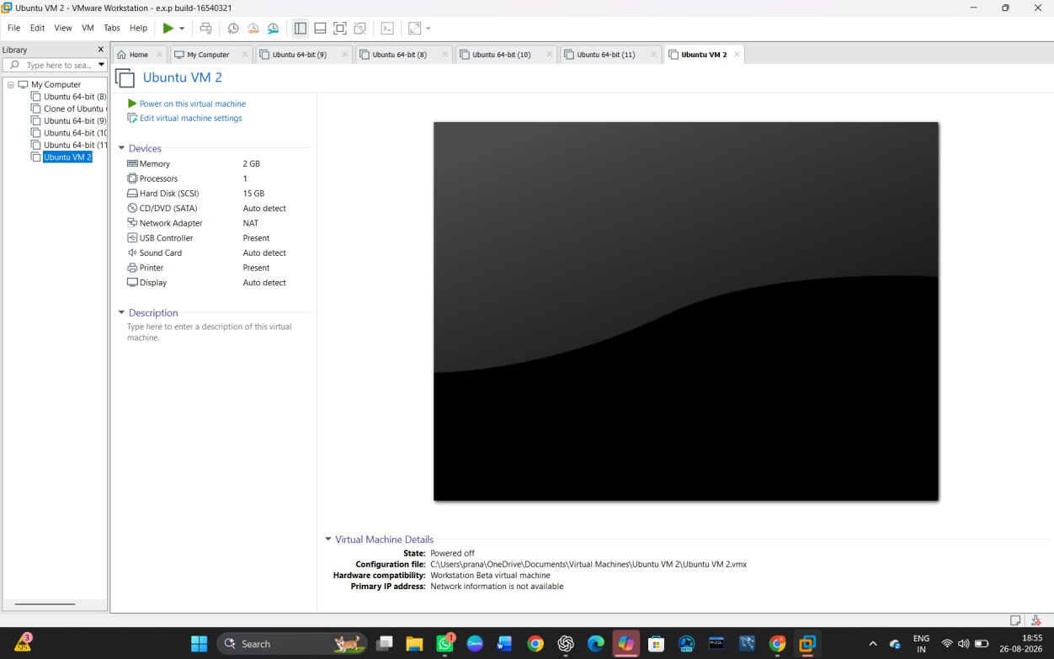

STEP 4 — Start the First VM

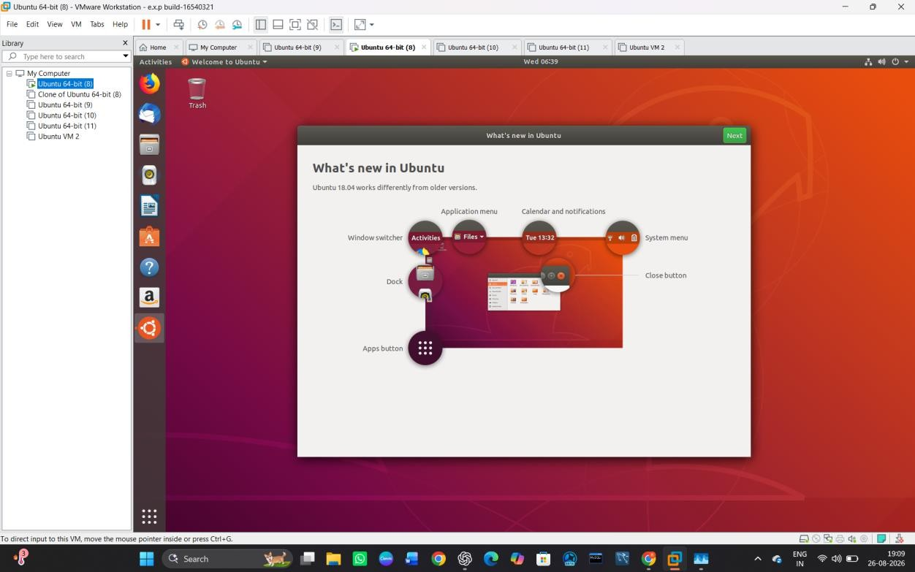
STEP 5 — Check the Host Resources
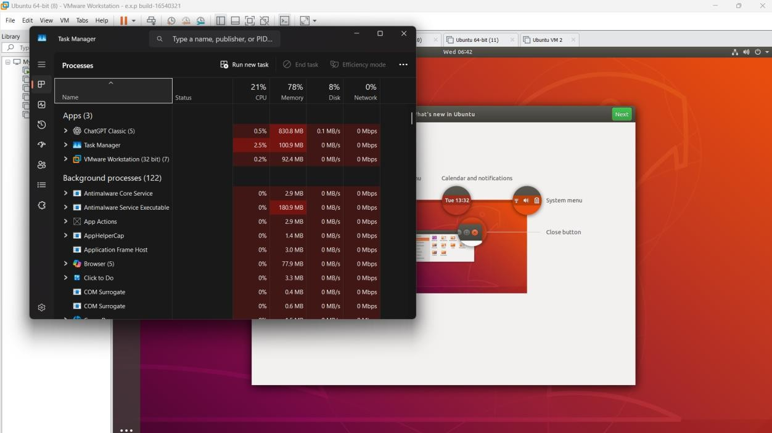

STEP 6 — Start the Second VM

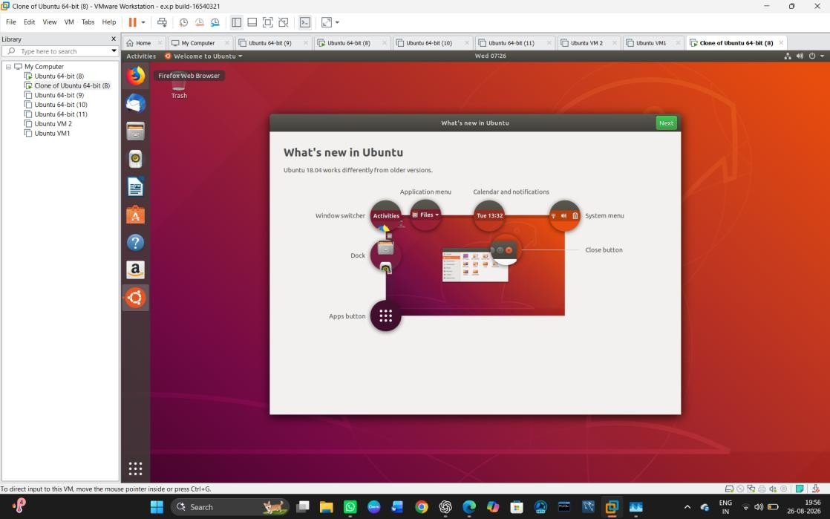
STEP 7 — Check the Second VM
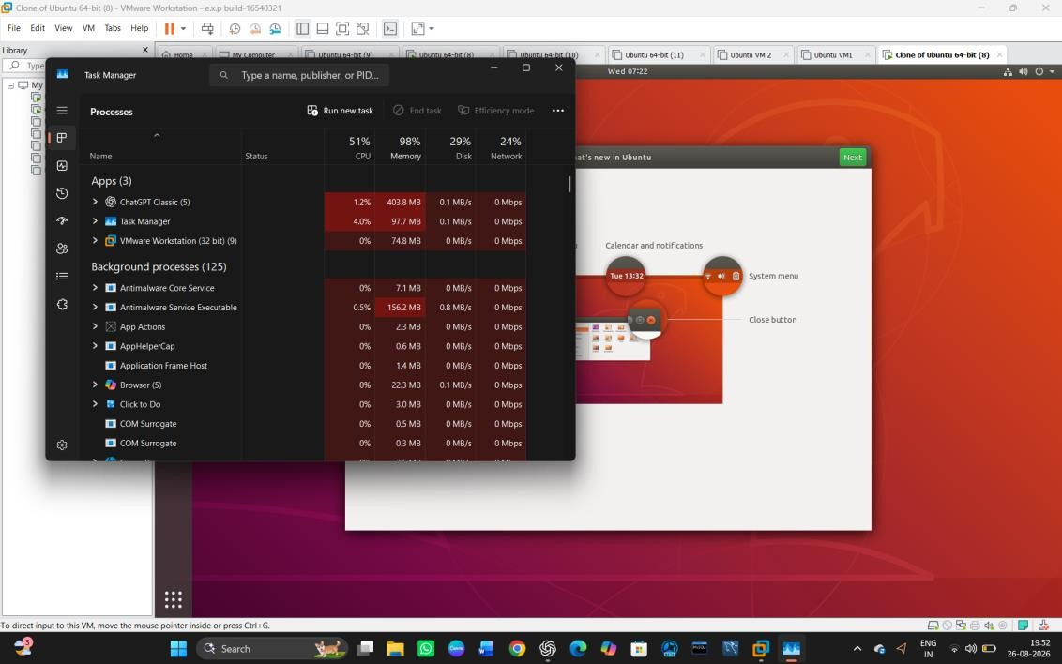

Result

Two virtual machines were successfully run simultaneously using VMware Workstation. The CPU and memory utilization were monitored using Windows Task Manager. When two VMs were running, memory utilization reached 98%, showing that the available system resources limited the number of VMs that could be utilized simultaneously.

Write a Procedure To Attach Virtual Block To The Virtual Machine And Check Whether It Holds the Data Even After The Release Of The Virtual Machine

AIM:

To attach a virtual block storage disk to a virtual machine, store data in it, release/detach the virtual machine, and verify that the data is retained.

PROCEDURE:

STEP 1: Open VMware Workstation.
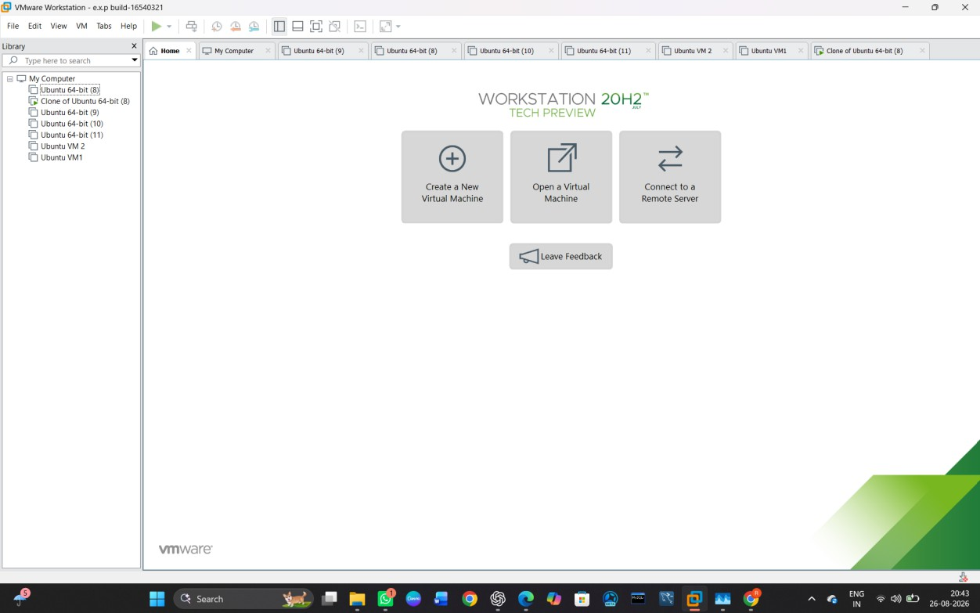

STEP 2: Select the Ubuntu Virtual Machine and Power Off Ubuntu

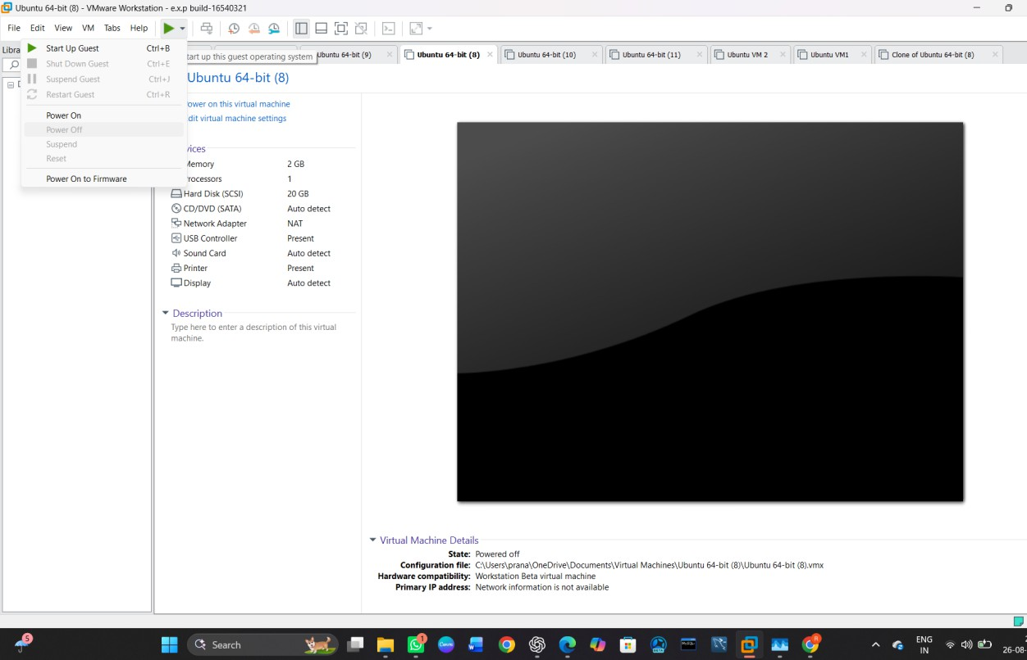

STEP 3 — Open Virtual Machine Settings
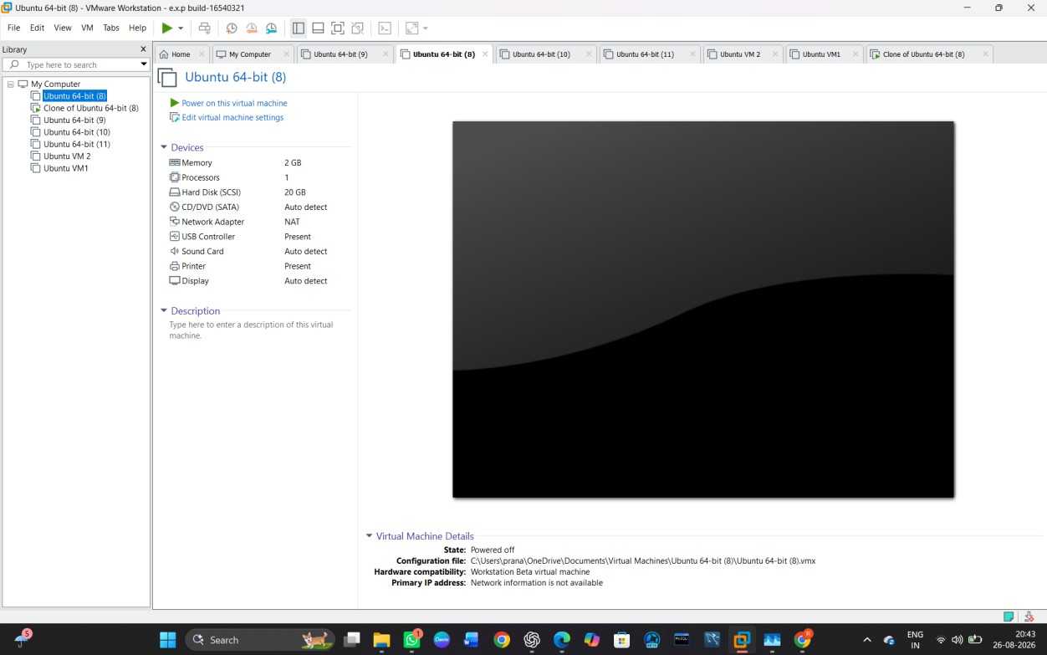

STEP 4 — Add a New Virtual Hard Disk

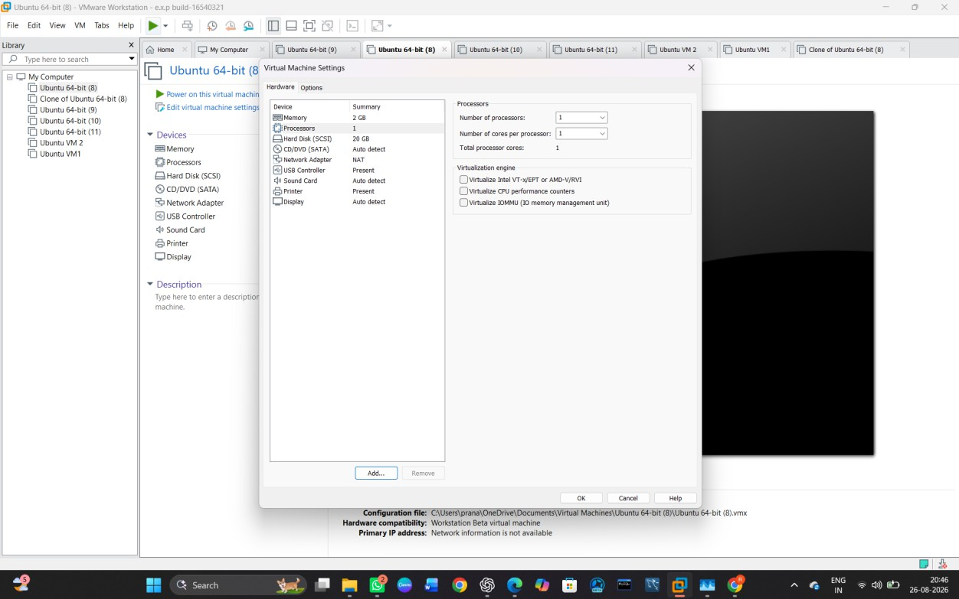

STEP 5 — Select Disk Type
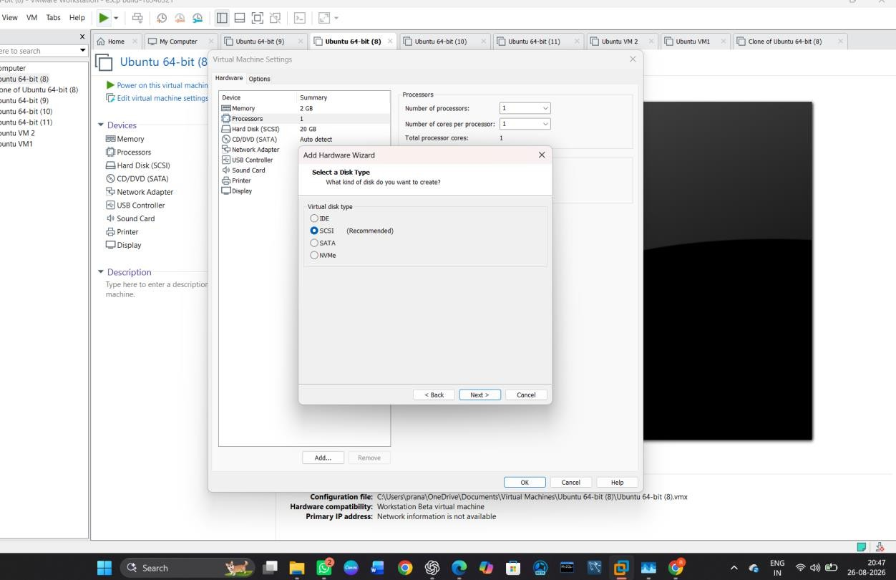

STEP 6 — Create a New Virtual Disk

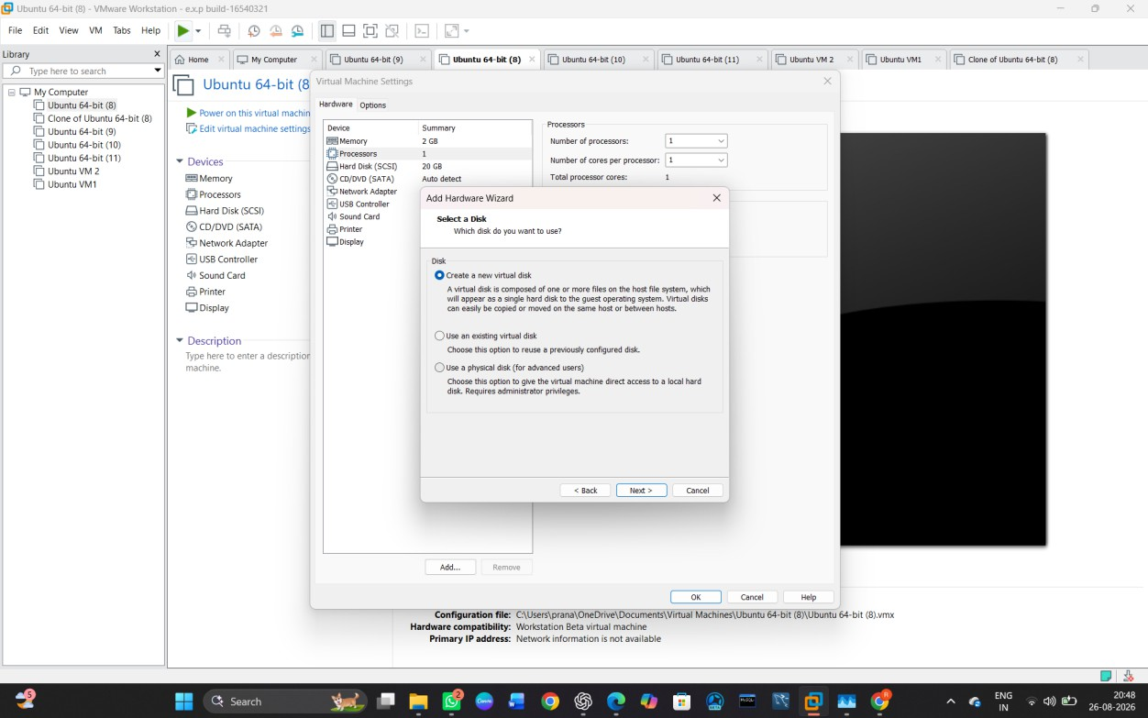

STEP 7— Set Disk Capacity
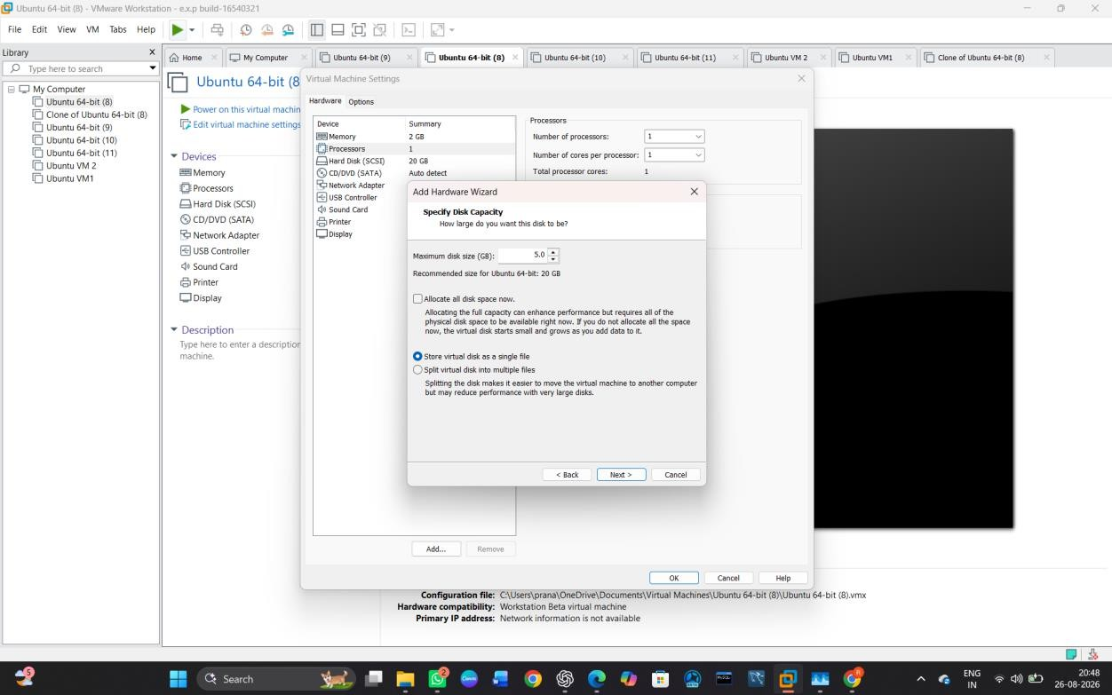

STEP 8 — Specify the Disk File

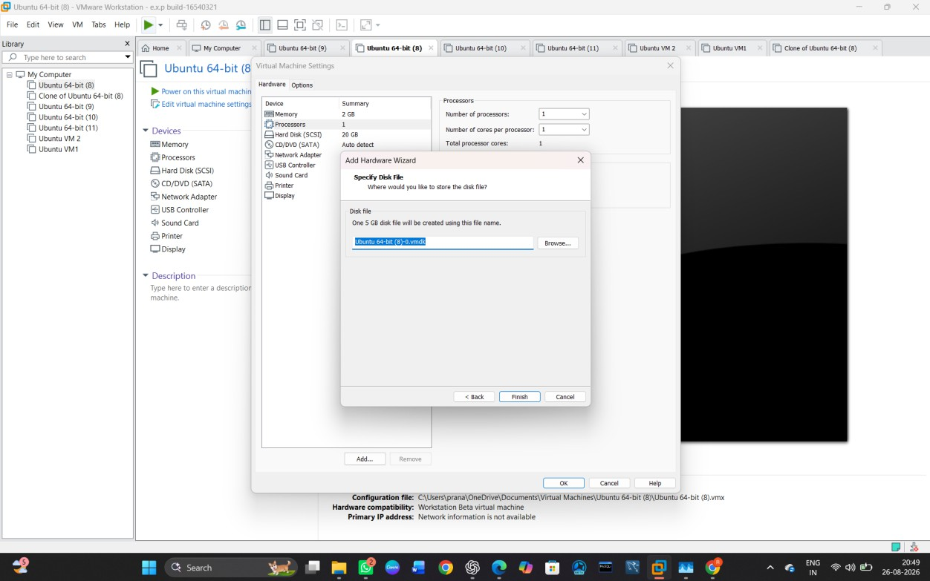

STEP 9 — Confirm the New Disk
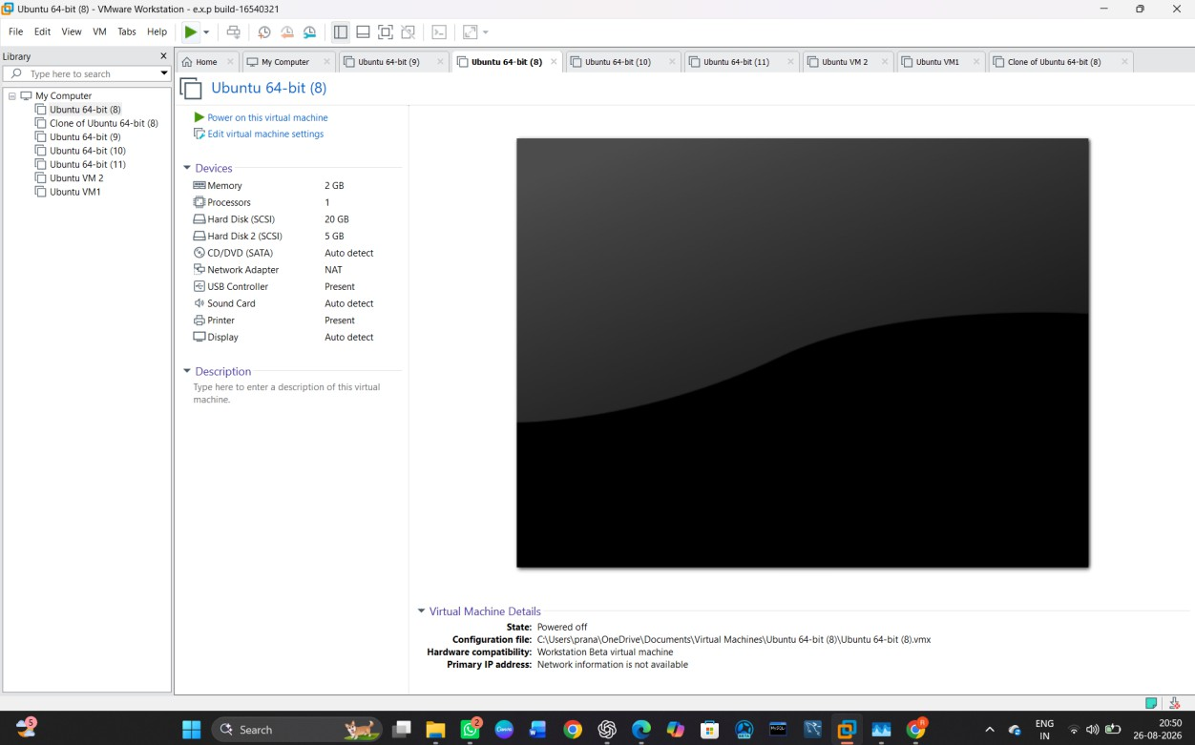

STEP 10 — Check the New Virtual Disk

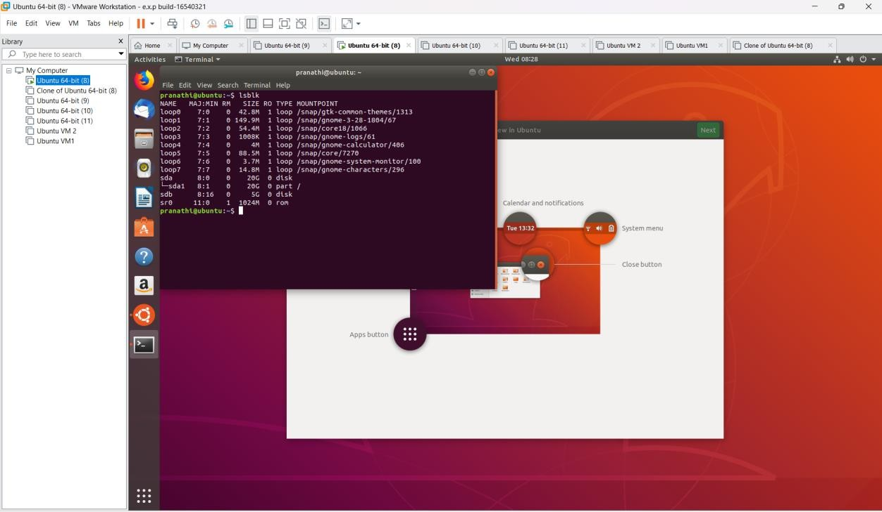

STEP 11 — Create a Partition on the New Disk
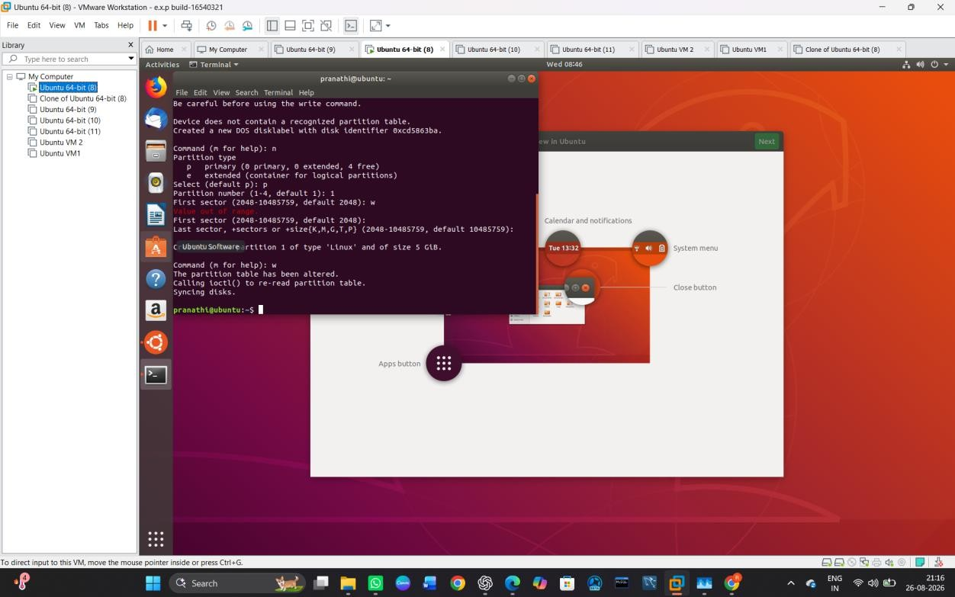

STEP 12 — Format the New Partition

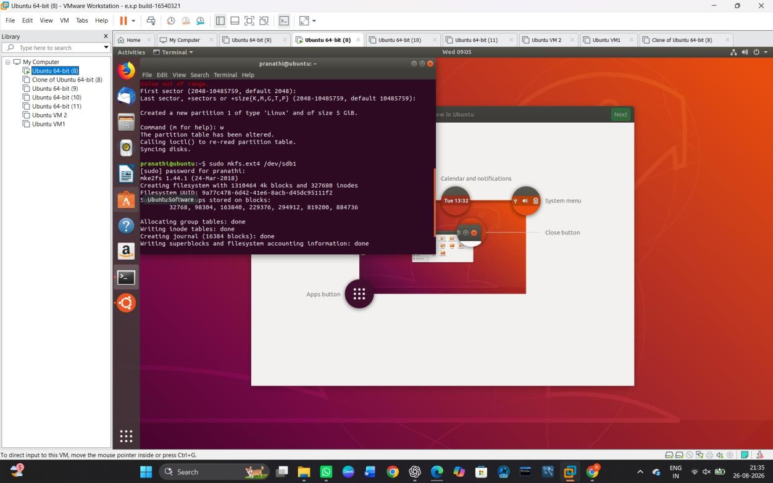

STEP 13 — Create a Mount Point
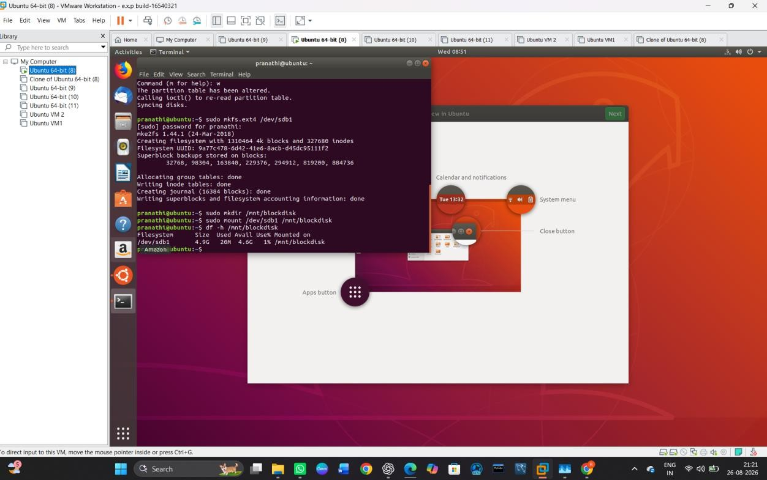

STEP 14 — Create Test Data

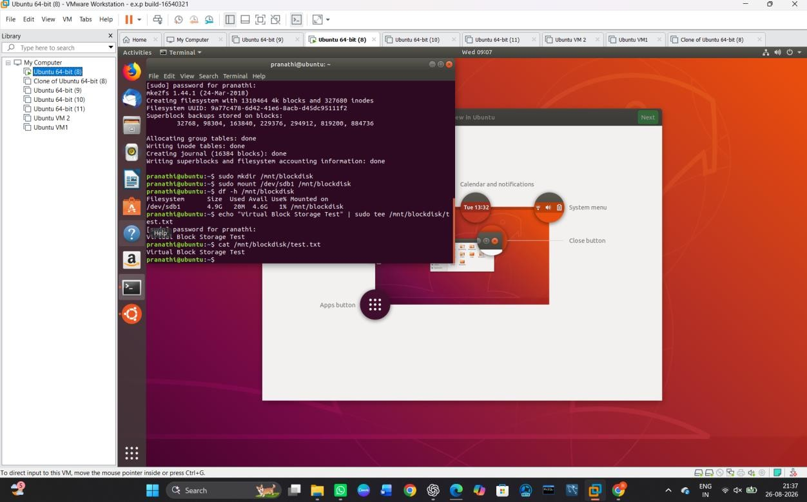

STEP 15 — Shut Down the Virtual Machine
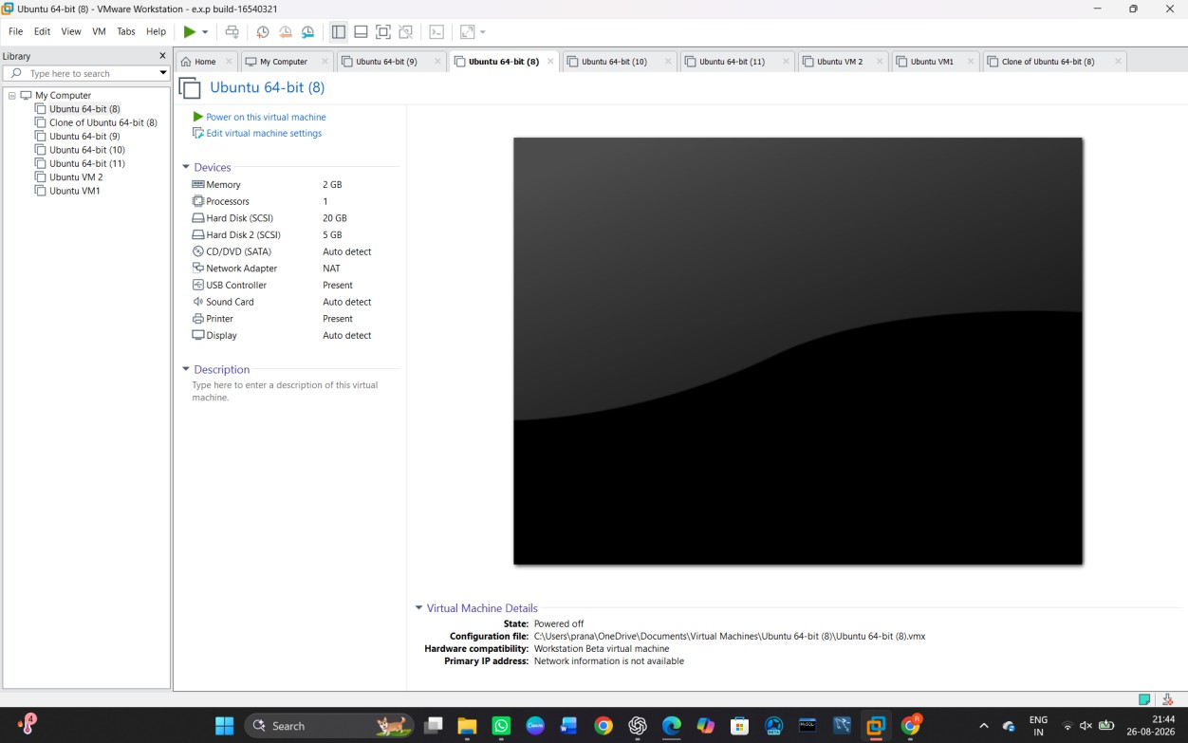

STEP 16 — Detach the Virtual Disk

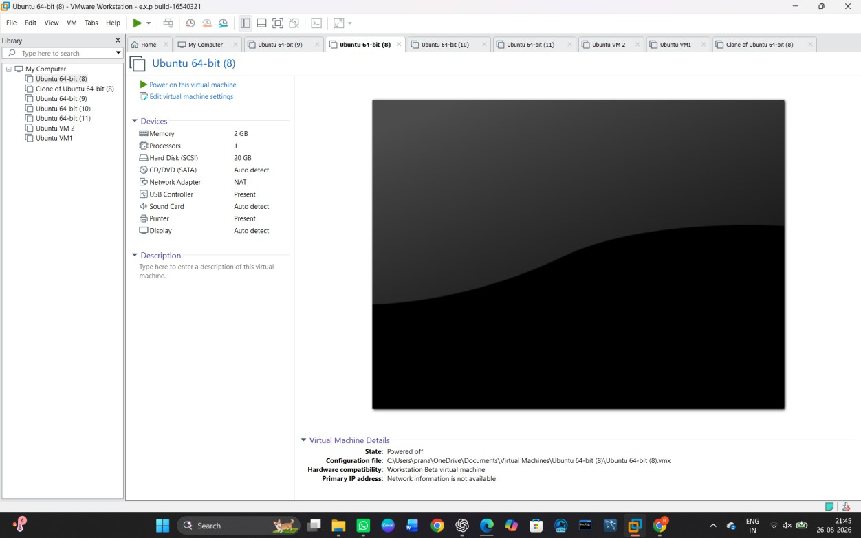

STEP 17 — Attach the Existing Virtual Disk
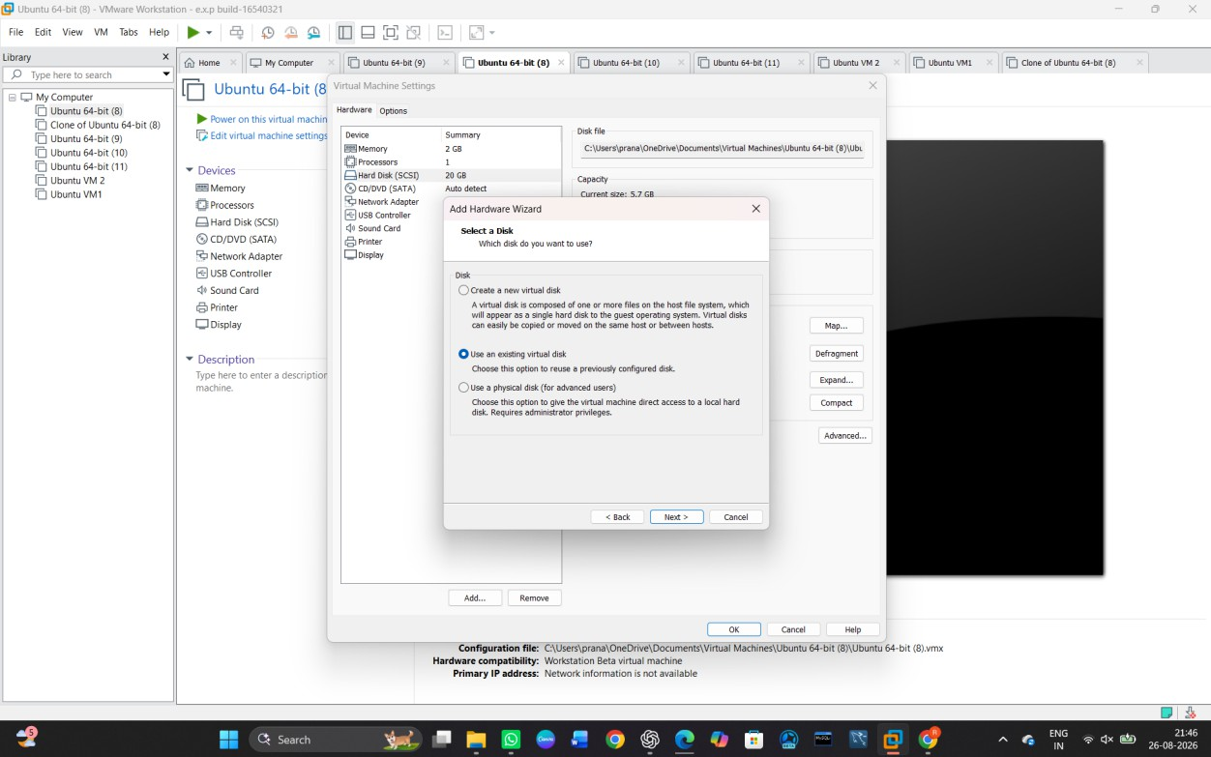

STEP 18 — Start Ubuntu Again

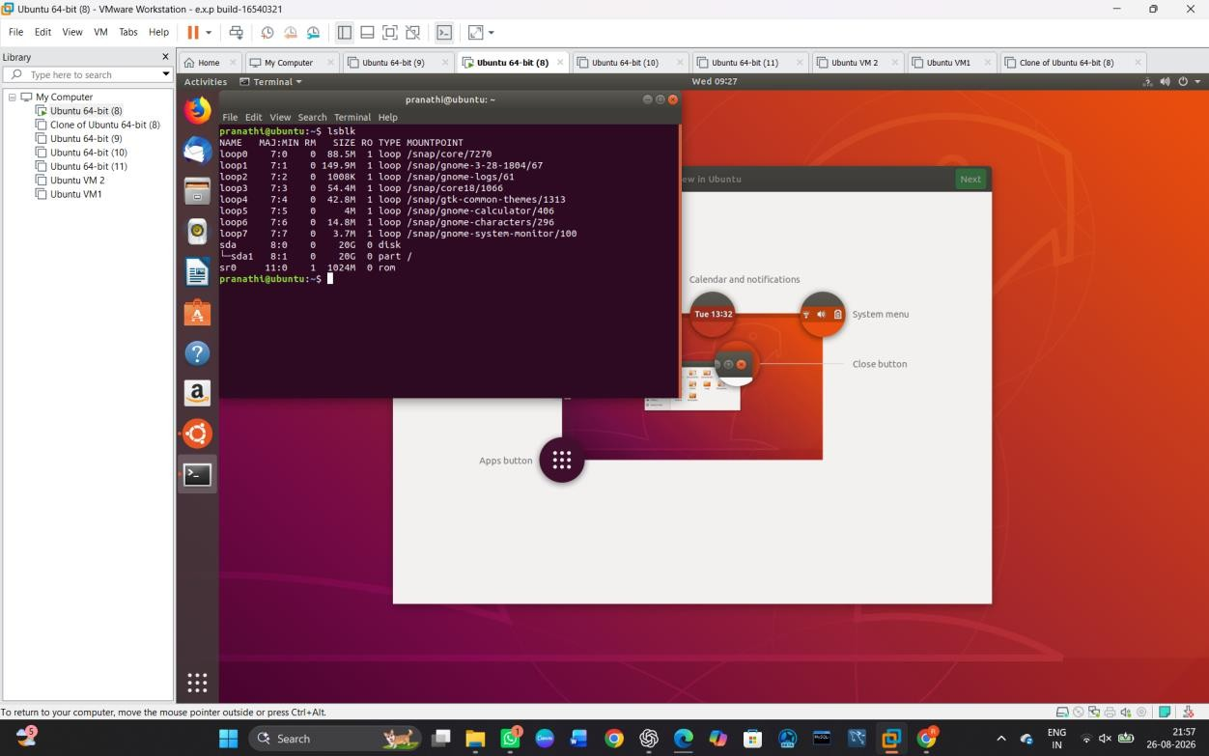

Result

The virtual block disk was successfully attached to the virtual machine. Data was stored on the disk, the disk was detached and reattached, and the previously stored data was
successfully recovered. Hence, the virtual block storage retains data even after the release of the virtual machine.

To showcase the virtual machine migration based on the certain condition from one host to the other.

AIM:
To showcase virtual machine migration from one host to another based on a certain condition.

Procedure:
STEP 1 — Prepare the Source VM
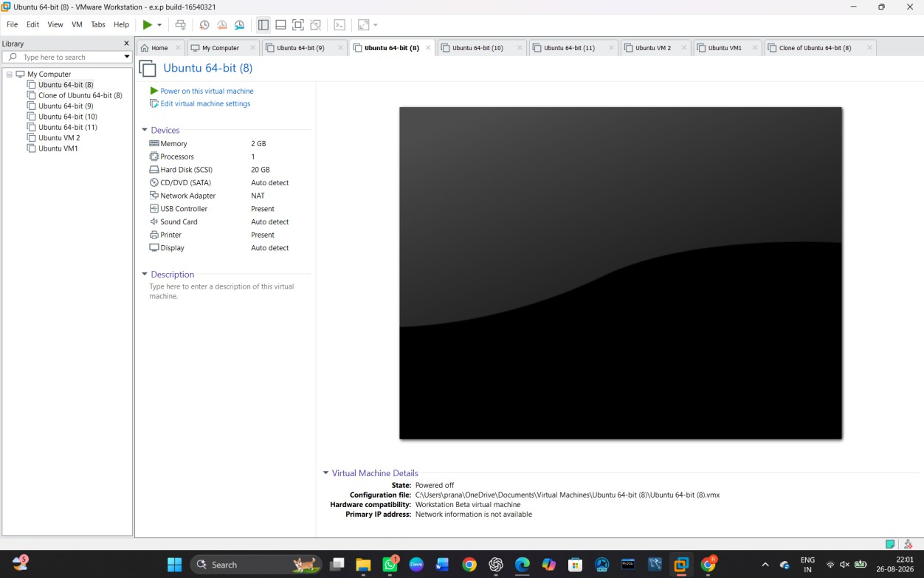

STEP 2 — Open the VM Folder

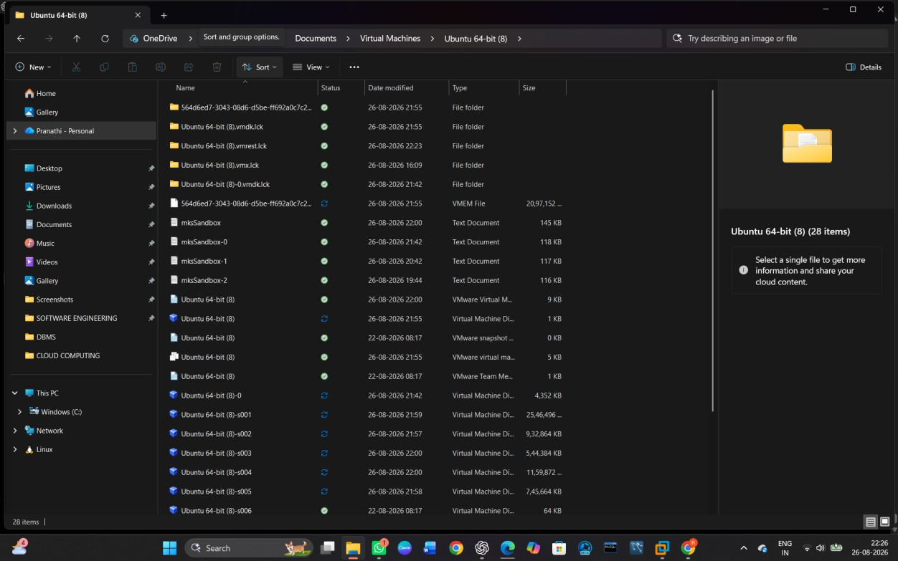

STEP 3 — Create the Destination Folder
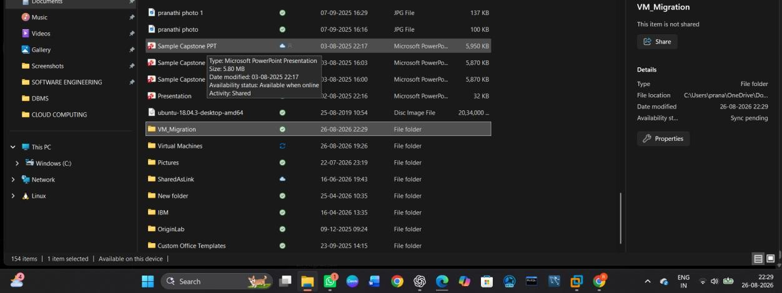

STEP 4 — Copy the Ubuntu VM

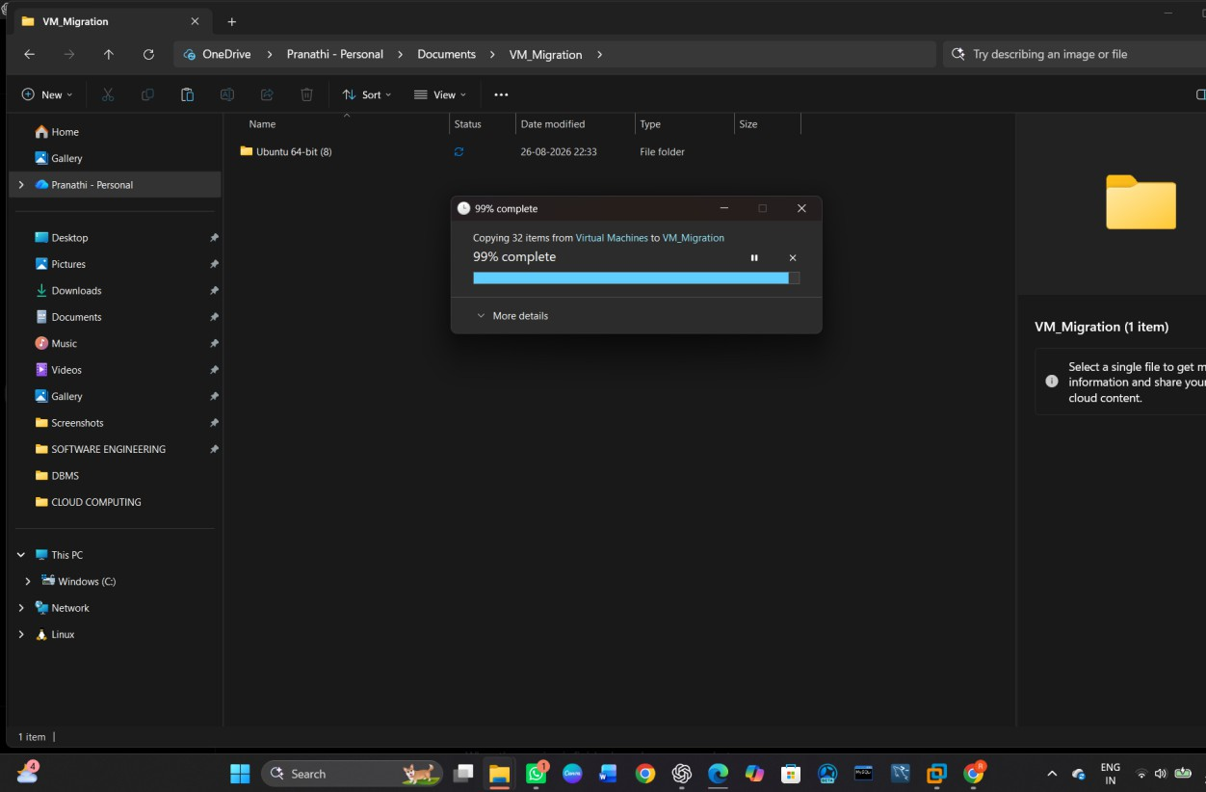
STEP 5 — Open the Copied VM Folder
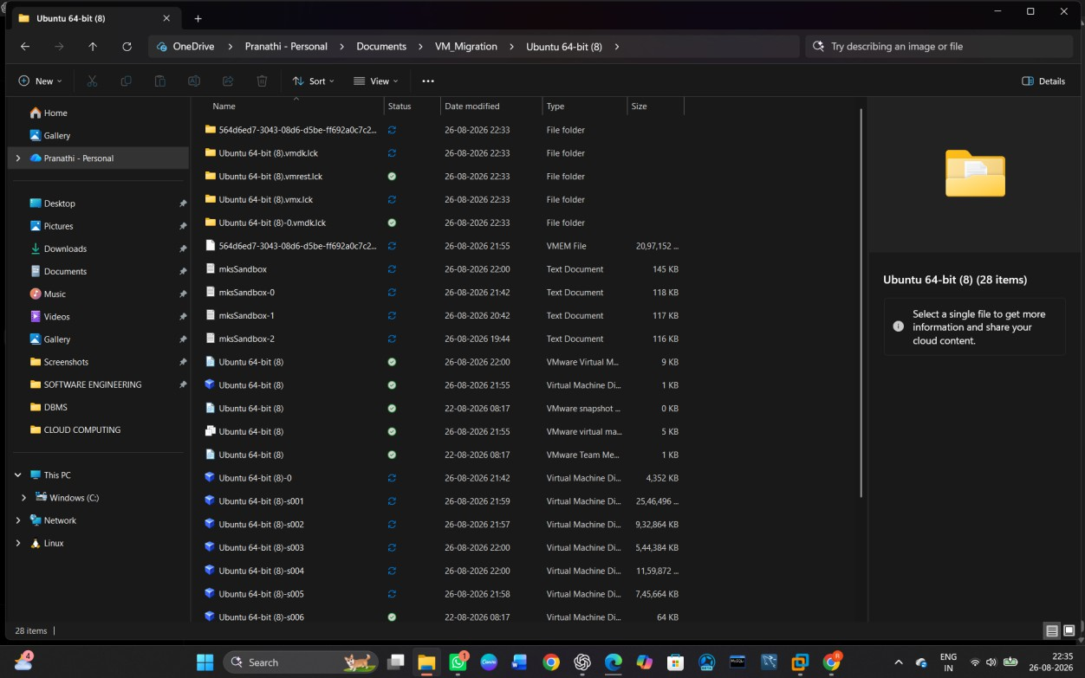

STEP 6 — Load the migrated VM in VMware Workstation.

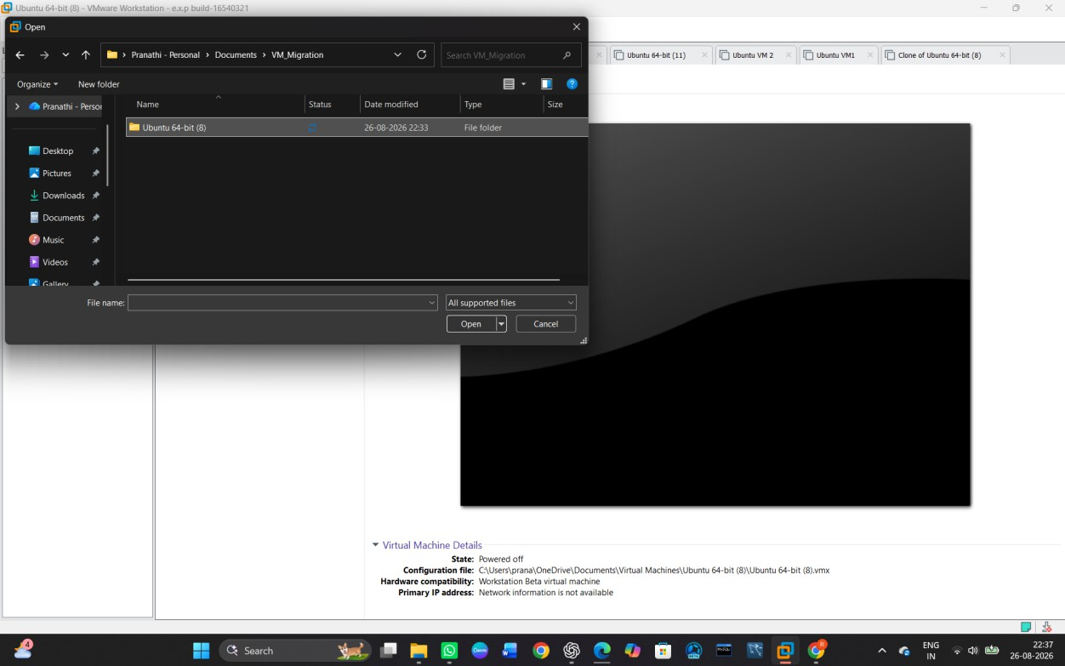
STEP 7 — Start the Migrated VM
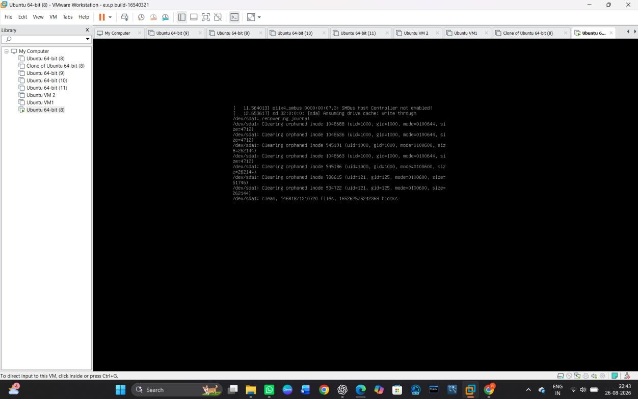

STEP 8 — Verify the Migration

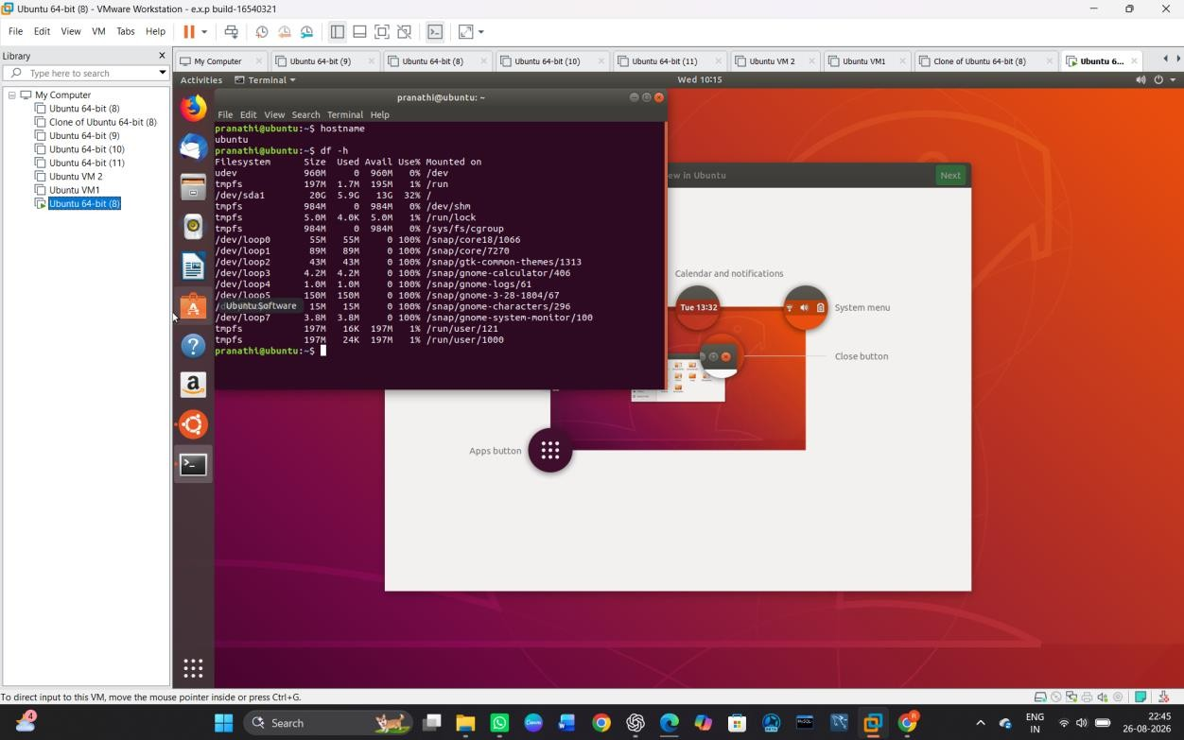
STEP 9 — Shut Down the Migrated VM
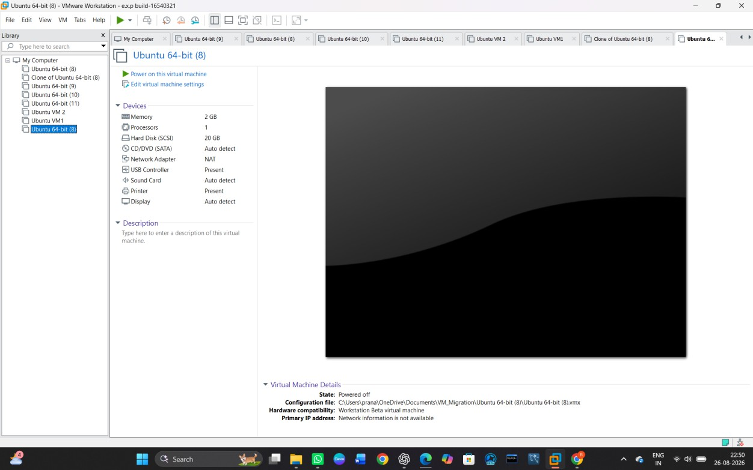

STEP 10 — Final Verification

